DICHOTOMIES OF FASHION
Bevica scholarship programme research proposal

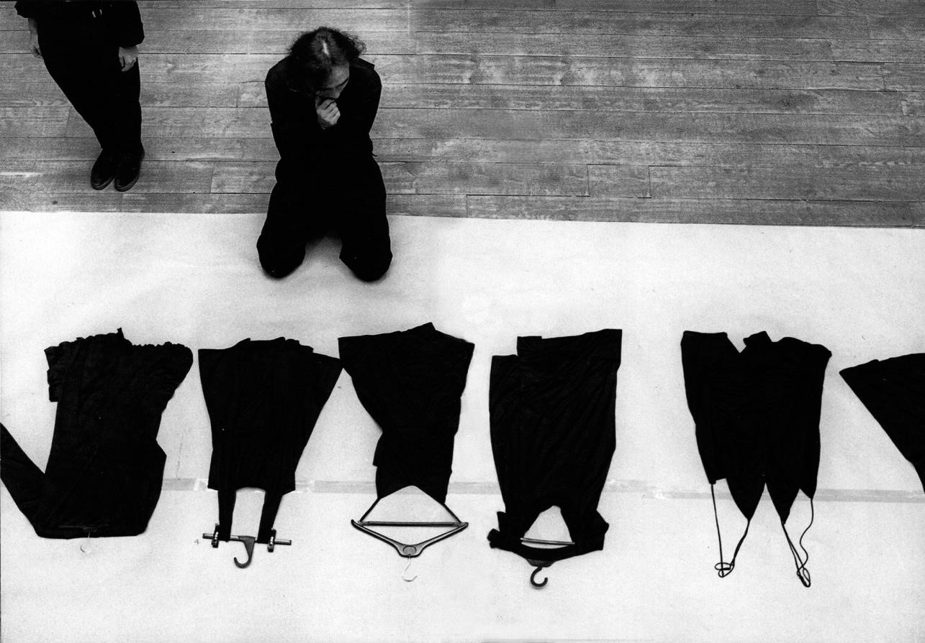
Yohji Yamamoto in studio, August 1985, Tokyo, Japan.

WHAT/SCOPE:

We all consume fashion to some extend because we all wear clothes. In our lifetimes, we spend more time in clothes, than out of them. Clothes touch our bodies, influence our moods, and help us express who we are. Their functions are complex and multifaceted, covering physical, psychological, and social needs. They help us express our identity as individuals and communicate which communities we belong to and where we see ourselves within our shared social hierarchies. Whether or not we are consciously aware of the power of clothes, we are all unequivocally affected by the intricate codified sub-contexts they express. So why is it that fashion’s incredible social power is never truly harnessed to drive forward more social inclusion and diversity, when the potential to do so, is so obviously present.

This question is my main catalyst, and it fuels my professional motivation to conduct this project. I want to challenge my students to look past systemic barriers and enable them to hack the system, so they can become true change makers and nurture new alternative narratives within fashion. This ambition has led me to formulate the following problem statement as a benchmark for my Bevica scholarship programme research proposal:

‘Can I create new educational tools or teaching activities for the Royal Danish Academy’s - Fashion, Clothing and Textile master’s degree, that will strengthen our students understanding of form-giving in relation to representation, diversity, and inclusion?’

For me to be able to achieve this goal I will need a framework to work from and I believe the following three objectives will help ensure a constructive approach to the project. Due to the broadness of the research areas that I need to access, and to ensure that the project is truly representational (in relation to age, gender, social equity, diversity, and inclusion etc.), it is vital that the framework enable me to process the knowledge generated constructively. That is why the knowledge gathering will focus on the following objectives:

- The first objective of ‘Dichotomies of Fashion’ is to explore alternative narratives to the prevailing western tradition within fashion, specifically related to form and purpose of clothing. Because we are arguably socially limited in our current understanding of form and purpose. We need to generate new knowledge to inform and help nuance teaching methodologies and develop new learning activities.

- The second objective is to investigate the limitations of Western standardization models within fashion design – with a specific focus on form and purpose. Because the current traditional Eurocentric approach to form giving is limited and arguably increasingly more excluding and anti-representational. Globalization is steering us towards faster production cycles and increased mass production which, in turn, is forcing us to simplify and standardize form and purpose in clothing.

- The third and final objective is to generate new design methodologies and design tools or learning activities. This is important because there is great potential and value in designing from alternative perspectives and we need more knowledge and research to support new teaching strategies in fashion design education that challenge the traditional approach.

So why is an alternative understanding of fashion form and purpose important for the Fashion, Clothing and Textile master’s degree program at the Royal Danish Academy? And how will this research proposal help generate a more inclusive society in a Danish context? The clearest answer is: Because our students are the future, and they will be instrumental in shaping it. If we challenge them, through education, to see the world in grayscale rather than black and white, we enable them to offer new narratives and innovative solution. To do this, we want the students to acquire the skills necessary to be able to hack the system and create new narratives within their work, and subsequently in their future careers. Only then will they become true change makers within the Danish fashion industry. Only then will we have the capacity to create a more inclusive future society in Denmark – in products, environments, and services related to fashion and clothing.

HOW/PROJECT PLAN

Firstly, a research trip to a selected Japanese educational environment that will form the basic knowledge pillar of the project. Secondly, a research trip to a selected educational environment in the US where key insights and preliminary teaching material and curriculum will be further tested and develop. Thirdly, and continuously, insights and results of the suggested project will be implemented in the teaching plans, detailed semester planning, design briefs, and capacity building (staff involvement) of the master’s programme ‘Fashion, Clothing
& Textiles – New Landscapes for Change’ at the Royal Danish Academy.

Research trip to Japan

There are several factors that makes Japan a unique place of interest in relation to this research proposal. BUNKA offers a range of fashion degree programs and the institution have a lauded tradition for fostering new alternative thinkers - especially in relation to unorthodox form-giving and progressive form understanding. This academic and practical educational institution is also arguably situated outside the traditional eurocentric fashion power structure of London, Milan and Paris but still effect significant international influence within the industry.

The country of Japan also has a very strong national design heritage and a complex history when it comes to fashion and clothes. Although the country was never formally colonized, Japanese society has experienced profound influencing through Western colonialism from a fashion perspective, especially within their dress culture. Japan became the world’s largest consumers of western luxury goods towards the end of the 1980s. But then the country’s economic bubble burst and that resulted in a complete shift and subsequent rise in cultural nationalism that also included fashion and form-understanding (Toby Slade 2020). The average Japanese consumer also generally fall outside utopian Western standardization and idealization models from a physical point of view. This is reflected through the collective difficulty many Japanese men and women experience when engaging with clothes designed in the west (Toby Slade 2020). This is also arguable why Japanese designer have approached fashion with a different perspective and new bold aesthetical points of view. Indeed, Japanese designers have significantly influenced the direction of Western fashion since the early 1980s and continue to do so today – from early visionaries like Issey Miyake and Rei Kawakubo to modern innovators such as Chitose Abe and Takahiro Miyashita.

All these factors, viewed collectively, support the stipulation that Japanese fashion culture and demographics form a key area of interest in relation to gathering the necessary knowledge to begin developing my Universal Design based teaching tools and activities. The following section we will outline the different faculty involved in the visit to Japan and detail the practical research activities proposed in a summary form.

1-2 week stay in Tokyo.
Academic institutions and faculty:
BUNKA University - Yoko Takagi, professor, and program director for Global Fashion Concentration
MA program + Transboundary Fashion seminars creator.)
Practical Workshop Experiments I - Kimino Homma, Master Pattern-Cutter. (confirmed)
Practical Workshop Experiments II - Manabu Kaminaga, Master Pattern-Cutter (- Sendai - not confirmed.)

- Facilitate 1-Day creative ideation workshops (practical and academic) with students at BUNKA to develop new form-giving methodologies, future learning activities and creative processes that are more inclusive. These exercises will revolve around approaching form giving from an alternative non-western perspective. The workshop aims to be innovative, explorative, and questioning rather than result led.

- Conduct personal pattern-cutting exploration research with Kimino Homma (- and possibly Manabu Kaminaga if confirmed-) that focused on new approaches to alternative design and form-giving. This practical research is necessary to inform and inspire own understanding which in turn will help develop new experienced knowledge that can help underpin future educational tools and practices.

- Explore the Japanese perspective on form-giving with BUNKA’s Professor and Program Director for Global Fashion Concentration MA program + Transboundary Fashion seminars creator, Yoko Takagi. This will help us build our understanding and hopefully also initiate an international network for knowledge sharing with like-minded professionals and academics from other Japanese institutions, ultimately enabling our cohort in Denmark to draw from a much larger international pool of knowledge.

Sparring trip to USA

Initially the intention was to stay clear of countries and institutions that fell within a global north, western or eurocentric perspective. Parsons – the New School of Design is a leading educational environment that has for many years been delivering new talent to the Western fashion industry. However, a refiguration of the School of Fashion have meant that the new fashion program is emerging with a particular focus on more inclusive and diverse fashion narratives, design development, and user-inclusion. Parsons thereby forms a valuable collaborative partner in terms of sparring and further development of the knowledge obtained in Japan. The suggested activities for the USA fieldtrip are outlined below:

1 week stay/New York.
Academic institutions:
Parsons New School of Design - Ben Barry, Dean at the New School of Fashion. (Confirmed)
Parsons New School of Design - Ulrich Lehmann, Professor of Design Practice and Theory at the New School of Fashion. (Confirmed)

- Peer review and ideation on how to formulate educational tool to achieve the best learning. In his role as Dean at the New School of Fashion Ben Barry has significant experience in developing Parsons educational programmes around topics of diversity and inclusion and represent a unique sparring partner.

- Knowledge sharing and academic sparring. Ulrich Lehmann, Professor of Design Practice and Theory, is a trusted source of knowledge in relation to the history of fashion, from a western perspective. This knowledge is essential for the project in relation to the aim of exploring the limitations of standardization and idealization.

- Exploration the American perspective in relation to the Danish and the Japanese. We hope that this academic networking and knowledge will enable us to include Parsons to our international network and knowledge pool.

Testing, developing and creating new tools and activities at the Royal Danish Academy
Before, during and after the suggested research trips, elements of the obtained knowledge from the project will be informing teaching plans, design briefs for semester projects, planning of supervirsion and guest lecturers, and exam delivery requirements from students.
Summary time plan proposed for Dichotomies of Fashion research proposal:
- 2 week research trip to Tokyo and Osaka, Japan – spring 2024.
- 1 week sparring trip to new York, USA – summer 2024.
- Ongoing - Testing and developing new educational tools and teaching activities – 2024/25.
This concludes the preliminary project plan in its present form. All suggested research activities are of course subject to final verification in relation to their feasibility. Several of the faculties and people involved have expressed their willingness to engage with the project but letters of participation from the educational institutions still need to be obtained. Because the research activities require participation from faculty across four educational institutions, significant planning will be necessary to ensure that individual semester plans, and teaching schedules aligned.

WHY/PROJECT IMPORTANTANCE

“Fashion schools have naturalized these exclusionary beliefs about bodies in every facet of their purview, from curricula to faculty hiring to student recruitment, perpetuating the logic of whiteness through the hegemony of European epistemology” Ben Barry Op-ed article for Business of Fashion, January 2020.

Ben Barry’s quote is about race and equity within fashion education, but I believe this is also equally relevant in a larger conversation about inclusion and equity. It cuts to the core of many of the issues that exist within the fashion industry but also in fashion education. If we are ever to achieve the UN pledge to Leave No One Behind we need to do so by creating the necessary space for alternative narratives to flourish within fashion design education. We need new tools that are unencumbered by current industry strategies and narratives.

At this stage I think it is important for me to state that I do not consider myself an academic but more of a reflecting practitioner who teach. This is probably because I have spent the first 20 years of my career as a designer within the industry at the highest international level, and only the past three years or so teaching Fashion Design at the Royal Danish Academy’s master program. But throughout my career, it became increasingly difficult not to reflect critically on the obvious paradigms of standardization and idealizations that exists within my industry. In my work, I was often faced with difficult and excluding aspects of the fashion industry, and this built into a strong personal desire to redirect fashion towards becoming a more positive future force for change and inclusion – hench the ’Dichotomies of Fashion’ scholarship programme research proposal.

In my opinion, fashion exists through the commercialization of a concept of beauty, and this subsequently means that, at its core, fashion also promote and nurture exclusion. The concept of fashion (-the one we have cultivated commercially and culturally from the global north for the past 70-80 years-) is in many ways based on an instinctual human desire to be admired or to belong to something. The driving commercial force of fashion today is to make people aspire to join a metaphysical community for the few and the ‘included’ – like an exclusive society or club. Thus, modern fashion feeds off a need for acceptance and an aspirational desire to belong. This is a powerful narrative and one that perpetuates exclusion. This is also arguably the reason why the fashion industry has been so infinitely slow in embracing people that exist outside the carefully orchestrated fantasy. Inclusion has the potential to jeopardize the narrative. It would make fashion real and, in some ways, attainable. And if anyone can have it, then how can the industry justify fashion as a symbol of aspiration and exclusivity? How would we then determine fashion’s worth from a commercial perspective? Inclusion, in many ways, represent a perceived loss of value in fashion and is counterproductive to the current strategic system or thinking. To my mind this represents a deeply flawed and problematic mindset.

Fashion was not always like this. Before the emergence of Ready to Wear in the 1960s the world still had some diversity in fashion and clothes (Kat Sark 2022). Back then the individual was still largely at the center of the creative process and all clothes had an intended user. Fashion also still existed outside the global north. But, as globalization slowly grew to envelop the world, our differences was quietly replaced with standardized or idealized expression of who and what we are supposed to express ourselves in clothes. Because of this process, people with different ethnicities, abilities, genders, sexualities, ages, and social status (to name just a few areas) have all been broadly discriminated against and excluded (Sandra Niessen 2020). We have come to favor the ‘one size fits all’ model in our understanding of fashion, clothes, and subsequently in shared values. Industry controls the narrative and there is more than a touch of neo-colonial powerplay embedded in this control (Moussa Mchangama, 2023).

However, if we stop to examine the current paradigms of fashion more closely, none of us really fit this definition of utopian ideals (Todd Rose 2016). So why do we accept this industry definition of fashion and form? ‘Dichotomies of Fashion’ wants to highlight the value in recognizing how infinitely diverse and unique we all are as individual. The resulting educational tools or teaching activities should help us celebrate people of different ability and backgrounds instead of generalized ideals. Because it all starts with education. Education is the key to effect long-term change and the only way positively steer our future Danish society towards inclusion. This is at the core of my professional interest and were I see the true value in the research proposal. I want to explore and promote a deeper understanding of form-giving in fashion. I want to help my students explore alternative narratives that breaks with the standardized model and engage with real people with different backgrounds to understand their needs. I want them to think of inclusion as a natural element in a creative design process and be inspired by our differences as well as our similarities.

Bern Barry also stated in the same article that: “The purpose of fashion education isn’t to serve the fashion industry; it’s to lead it. Leading the industry means teaching the next generation how fashion has benefited certain groups by marginalizing others and then working to redress it” (Ben Barry Op-ed article for Business of Fashion, January 2020.) This quote was also in relation to race and equity but again the point of view is very poignant. Because it helps focus the opportunities and responsibilities we have as educators within this field and opens the doors of real potential.

LITERATURE LIST

Masashi Kajita – ‘What kind of bodies do architects imagine when designing’ I D. Hauderowicz , & K. Ly Serena (red.), Age-Inclusive Public Space (s. 116-119). Hatje Cantz Verlag. (2020)

Toby Slade – ‘Decolonizing Luxury Fashion in Japan’ published in Fashion Theory, 2020.

Todd Rose – ‘The end of Average’ 2016 Harper Collins

Jos Boys – thinking/designing form inclusion. ‘Doing Dis/ability and Architecture Differently’ lecture at the AA School of Architecture. London, 2016.

Camilla Ryhl – ‘Universal Design – introduction to a design principle that challenges the idea of being human’ Ryhl, C. Eriksson, M. Overby Sørensen, R. August 2021.

Sandra Niessen – ‘State of Fashion’ article 2020 for the Research Collective for Decoloniality and Fashion.

Sandra Niessen – ‘Fashion, its Sacrificial Zone and Sustainability’ article published in Fashion Theory, volume 24, issue 6, 2020.

Kat Sark – ‘Decolonizing Fashion Education and Industry’ lecture at The Royal Danish Academy. Copenhagen, February 2022.

Moussa Mchangama/In futurum – ‘New ways for responsible business’ lecture at The Royal Danish Academy. Copenhagen, March 2023.

Javier Romanach & Manuel Lobato – ‘Functional diversity, a new term in the struggle for dignity in the diversity of the human being’ article in Independent Living Forum, 2005.

Ben Barry – ‘How to transform fashion education: A manifesto for equity, inclusion and decolonization’ International Journal of Fashion Studies, Volume 8, Number 8, June 2021 and Op-ed article for Business of Fashion, January 2020.

