NAF/NAAR Symposium 2021 - Concepts of Transformation
Academic Essay - Preferred Track: 3. Representation and architectural transformations
Representation of architecture through virtual media
Abstract:
How can architects, and architecture in general, benefit from the emerging digital media and tools such as virtual reality, eye tracking, EEG analysis and the new insights gained from neurology in relation to perception in the past decades? This essay will discuss recent research into these fields exemplified in the development of an engaging representational model using a combination of feedback logging mechanisms in virtual reality to indicate the quality of universal design and of architecture. During the last five years, a series of experiments have led us to the prototyping an architectural transformation and design tool, with the intent to extract both the feedback of behaviour and emotion using a digital architectural representational model. Combining digital scans of existing architecture with suggestions of architectural transformations, allows the prototype tool to provide a more informed and detailed basis for decision making. With this ambition of working in the virtual digital realm and at the same time investigate and stress the importance of the human mind engaging with the representation of architecture with all its floors, walls, and atmospheres, it can be a complicated issue to establish a common frame of reference explaining why certain aspects in a representation are preferred and others are not. This use of architectural representational models eventually holds the potential to further improve the experience and quality of architecture and architectural transformation.
Keywords:
Digital representation, perception, atmosphere, virtual reality

Introduction
If architectural space, in Pallasma’s words, is lived space rather than physical space, and lived space always transcends geometry and measurability, how do we then approach the assessment of architectural quality? This essay argues for, and wants to discuss, how a journey into architecture and the realms of neurology could generate new input to the discussion of representing architecture and possibly to the quality of architecture itself. While the complexity of each of the topics brought together in this essay should under no circumstances be trivialized, certain discretionary limitations must be applied, in order to investigate the possible meaningful coincidences and comparisons, not to mention attempting to reach any sort of conclusion to this vast canvas of human biological perception and idiosyncratic preferences in the world of architectural aesthetic and physical feasibility. That is also the reason why an essayistic form has been chosen for this article, though also many references to scientific work will occur. In addition to this, a definition of the concept of representation in the transformation of architecture will be addressed. Knowledge about perception of space is crucial to architects, and in the transformation of something into something new, the representation often plays a vital role. While transformations of matter on a smaller scale, i.e. design objects, can be undertaken in 1:1 scale, the nature of buildings and urban transformations require the use of scale models e.g. architectural representational models, that can vary in size and performance and materiality, but almost always operate as a downscaled model, to make it feasible to produce. This ambivalence of an application of architectural representation that is always showing something, but in its nature never everything, is thus in this essay handled as a necessity of the profession, a facilitator for the creation of architecture. A wooden architectural model can be pleasing and aesthetic in itself, but as a tool, it remains a means to approach the vision and accomplishment of the real building. When dealing with digital representations of architecture, there are several other issues at stake. For instance, there is a lack of tactility and a supposed lack of scale. While the issue of scale is a comprehensive argument on its own, it will suffice here to hypothesize, that a digital model in virtual reality differs from the other digital representations by the fact that the user can immerse him- og herself into a 1:1 scale model of an architectural model. This distinction between different modes of application of digital models are important for the discussion and argument of this essay. The tactility on the other side, the lack of haptic response from digital images is another issue, but perhaps not so far from the actual lack of tactility in other representational media. This will also be open for discussion later in the essay. However interesting the digital models and the world of virtual reality can be in other contexts, i.e. in the vast world of gaming, the virtual reality models used for architecture are tools to obtain better quality in the transformation of real matter into real buildings, and hence in this essay not viewed, as meaningful worlds detached from this tool-specific architectural purpose. The virtual representational model, as seen in this context, can be a logical addition to the tool palette of the architect, representing a possible next step into the discussion about perception. Learning from the last decades how can we, with the knowledge gained from technological development and neurological insight, establish a use of digital virtual reality representational models in architecture that come close enough to the reality of human perception to make it a useful tool in design and transformation of architectural projects.

Background of a neurological approach to representations of architecture
Already in the early dialectic phenomenology of Maurice Merleau-Ponty the perceptual consciousness is a combination of the physical world and the intentionality of the cultural level of human life that cannot be isolated from either part without losing its inherent meaning. Attempting to describing the world requires an understanding of the interrelatedness of the physical world, which we humans are essentially part of, with the fundamental mechanics of perception going on in the brain. This relation of body, consciousness, and perception resulting in attempts to define a phenomenological structure of perception has continued to intrigue us pointing to the idea that vision is always pregnant with meaning. A meaning that, to some degree, is unrelated to the perceived. The body is the general instrument of comprehension of the perceived world and the fabric into which all perceived objects are woven. Phenomenology, occupied with the phenomenal world, continues from the personal experiences and observations through Pallasmaa’s articulations of architectural experiences as framing, relating and giving significance to the life unfolding and his concern with a too limited focus on the sense of vision when working with architectural design and transformation through representations. Considering the critique that architecture is not merely a series of retinal images but are indeed encounters and confrontations in relation to existing memory, we must incorporate this knowledge in the digital models, so we can in fact discuss and expand on the usability of digital virtual systems, which are in their primal functionality using sight as a direct link to immersion into the representations of architectural design and transformation. The neurobiologist Semir Zeki has for many years explored the brain in relation to visual art and many of the neurological findings are becoming important for the understanding of perception. Zeki explains how the major finding, that there are many other visual areas than the primary visual cortex in the brain, changed our concept of vision as a process. This active brain process of discarding, selecting, comparing with already stored information, generates a visual image in the brain. In this way the brain creates the visual world around us as an active process, and not just passively registering a static image of the world that already exists. Hence a perceived perspective or a perceived object is not describing the situation of a specific location or object, but rather the situation of the spectator. The brain never perceives the objects and surfaces surrounding us from a single point, but from different distances, from different angles and in different lighting conditions – but it even still recognize the objects and surfaces. Even though there exist no colours besides the construction of them in our brain, we still see them as if they were out in the world. The different visual areas in the brain are also perceiving in a temporal hierarchy where colour is perceived before form which is then perceived before motion. The brain will register the colour change first, in an object simultaneously changing both direction and colour. Zeki describes this temporal lag as ‘microconsciousnesses’ all processing the events at slightly different times which also indicates that we are never really in one common present, in relation to our perceptual understanding of the world. The understanding of the brain has changed from the old model, which like a computer passively took outer stimuli from the senses, to a much more active model of the brain that confronts what it senses with its own representational models based on experience, and constantly tests and evaluates its hypothesis. This also suggests that the senses are not separate from the brain, and that the old distinction between body and mind are making less sense in a neurological perspective. The neurons in the hands or feet are just as much part of the brain as the neurons in the frontal lobe, the brain is the body. Several parallel processes are organizing perceptions distributed on fragmented locations in the brain and compared to previous experiences to produce a plausible explanation of the world. The rapid gist extraction allows the brain to create an image from only one fixation of an environment in order to discern what is most important. The rest of the mentally constructed image is filled out with our existing schemas and mental representations. A level of ambiguity characterizes each perception, as the brain, in its comparison to existing experiences, “guesses” or fills in the missing details, to make sense of the perception. Zeki describes this as many equally plausible interpretations that can each occupy the consciousness. The brain, so to say, holds the possibility to represent several truths with equal validity from a perception. This ambiguity is important to remember later in this essay in the discussion of the level of detail required in an architectural representation.
To turn our focus towards architecture, there are some examples that seem worth mentioning in this short background review. Architecture is activating many different areas of the brain, so the perception of e.g. a building façade, may be mentally processed both as a background and as a configuration of objects, likewise involving different areas of the brain. But is there a hierarchy in the sensation of form and surfaces on a more tangible macrolevel? Research into how both architects and non-architects react to different geometries have been undertaken to search for a connection between human feeling and architectural space. A continuation of that research topic has recently examined how emotional reactions to architectural space can be empirically measured and quantified using virtual reality representational models of architecture combined with physiological sensors, such as EEG, sweat sensors, and eye-tracking. Conclusions from the study point to a measurable neurological influence of architectural scale, proportion, protrusion and curvature to the users’ emotional state. Sarah Goldhagen describes in her work how the perception of form-based cues such as geometrical shapes, their sizes and orientation are located in parts of the brain that presumably does not require referring to the memories of previous encounters with similar forms. She describes how the use of geons, as a primal understanding of basic geometrical principles, allows us to understand the physical form as components of recognition in a rapid comprehension of the shapes and forms we experience. While the perception of shape and form are probably going on without the need to mentally consult the memory of actual experiences of similar forms, the brain behaves differently in relation to understanding surfaces. When making sense of different surface properties such as texture, density, colour or pattern, the brain draws upon memories of prior encounters and experiences with similar surface cues. The perception of surface, in comparison to form, is thus seemingly a more emotionally entangled process that involves a multisensory whole-body sensation to a higher degree than the perception of form. A very roughly textured concrete wall may invoke the sensation of being bruised against it, while a soft chair may invoke relaxation, even without sitting in it. This also becomes important for this essay when deciding and discussing how to apply virtual models in design and transformation processes, with or without textures. In a digital model, as mentioned earlier, the lack of tactility and texture can be an issue seen in this context of the importance of surface quality. However, we might look to another finding in neurology to discover suggestions in overcoming this physical absence in the virtual, at least to some degree. The canonical neurons controlling our motor actions are firing when we perform actions involving movement, but also when we are inspired to perform actions, e.g. by looking at a window and mentally preparing to open it. Mirror neurons are also firing when performing or thinking about performing actions, but they also fire when we are just watching another person performing an action. In this way these neurons are said to mirror the actions of what we observe others do. This could suggest that motor system and sensory faculties are two components in the same unified system in the brain. Merely looking at a stairway invoke the sensation of movement, a mental simulation one might say, even before walking the stairs, or even if not walking the stairs at all. This connects to imagination and to the human desire and ability to tell stories. The distributed neural networks that in the human central nervous system are creating narratives are essential for how we as humans define ourselves. Imagination and narration of stories inspired from the environment can take part without activating the motor apparatus, i.e. ‘decoupling’ from actually moving, in order to allow several narratives to inspire us, also in an artistic manner. The stories we tell are part of the dynamic process in the act of defining ourselves in the world. Architecture plays a role in this narration as focal point for deriving meaning and orientation from our environment and physical surroundings. All architecture contains a possibility to respond and provoke narratives in the people who moves around and dwell in it. When successfully engaging people, architecture can inspire stories, on a neurological level, that enrichen our lives and imagination. Perhaps being aware of the narrative, geometry and surfaces could be as important in the representational architectural model as in the actual built environment? We know from neuroscience that half of the sensory information going from the human body to the brain is visual, but also that these stimuli invoke sensations not limited to the visual aspect of cognition. This neurological connection is probably in line with the assumption many architects develop through the work with representational models. It is fundamental for the work with e.g. scale models, that we can imagine what this space could provide for us in full scale. Another ordinary example of this could be how watching a movie, through vision, can affect our feelings and invoke memories that generate the physical awareness of touch, smell, and bodily presence of. Laura Marks describes, through examples from movies, how images allow viewers to experience cinema with ‘haptic visuality’ as physical and multi-sensory embodiment. When working with a visual interface such as digital virtual reality, these are important learnings, that must be cleverly applied and balanced in the transformation phases of architectural design, to avoid losing important elements of what architecture holistically is and can.
What has been introduced so far, can hopefully serve as an explanation to some of decisions that has been made in our attempt to create a virtual reality representational system that can assist architects in working with transformation and designing of architecture. A link between the neurology of the brain and the perception of the world as a generative process where vision can play a role of invoking sensations that are not limited to the visual. In the next section we will introduce and look at some cases of research into the applied use of virtual reality in architecture.

Digital representations of architecture
The use of virtual reality has been a topic for many years, and in the last decades, with the introduction of low-cost equipment, the possibilities of application and testing this sort of technology have also become obvious within architecture. While digital 3d models on computer screens have been unavoidable as a part of the ‘virtual’ working methods for architects for a long time, it is not to be confused with the virtual reality experienced through head mounted displays (HMD), referred to in this essay. This technology is different from working with the traditional digital computational models on a flat screen, since the user is being situated inside the architectural model through a display mounted on their head. The experiences in the virtual reality model can be simulating the real world in a way so the user can look around and move through the architecture in a 1:1 scale. The HMD screen allows for a sensation of depth and parallax due to a slight correction of the viewpoint for the two eyes, based on the interpupillary distance of the user. That is one of the reasons the essay claims, that the digital representation of architecture is very different seen on a traditional flat two-dimensional screen and experienced through the HMD virtual reality. The sensation of being present or ‘immersed’ in the model is where the virtual reality model comes closer to reality than working with a traditional computer screen, and in some cases actually so close that it provides a scientific foundation for the study of presence. Research using the ‘mental rotation task’ of geometrical figures performed with both traditional flat computer screens and in virtual reality HMD shows that the traditional digital desktop graphics are ineffective or even counterproductive in relation to virtual reality 3d immersive environments if the goal is to simulate tasks in the real world. Virtual reality can in this case be said to generate a more ‘natural environment’ for the brain, than 2d computer screens. This natural environment has from research in the world of gaming suggested that the immersion and enjoyment is higher through virtual reality, but that the gaming performance was better using mouse and keyboard. However, the task performance of the world of gaming is of course not directly transferable to architectural experience of spaces, where the ‘task’ is not so easily defined. But the fact that the mind seems to be very flexible in its definition of a virtual self, the possibility of being someone else in virtual reality can prove to be very useful for architects. When designing for disabled people, the elderly, or for children, the opportunity to experience the architecture from the users’ point of view, is something that is a unique property of the virtual reality environment. In another neurology study that compares learning in virtual reality to learning through conventional flat computer screens, the conclusion shows that virtual reality increases both sense of immersion but also the risk of increasing processing demands on working memory, which in turn can lead to a decrease in knowledge acquisition. This is also important to remember when discussing how a virtual environment could, as good as possible, provide a platform for architectural work. Again, the level of included detail in the model could be of importance to avoid overinforming the user and keep the detailing to the minimal cues required for understanding of the architectural idea. It has been observed that the realism of the display seems to be far less important, for feeling present in the virtual reality model, than other parameters, such as head tracking, frame rate, sound and interacting. While some of these parameters are easier to accomplish than others in the virtual reality system for architecture, it resonates well with the traditional idea of an architectural representational model that operates on a level of abstraction from the real world, in order to show only what is most important.
In a study that focuses on emotion recognition in virtual reality using an architectural representational model, the potential of immersive virtual environments, or IVEs, shows promising results. In the study four alternative virtual rooms were designed, all based on Kazuyo Sejimas ‘Villa in the Forest’ to elicit four different kinds of experience based on altering of the surface properties, lighting, and geometry of the villa representational model. This branch of research, called Affective Computing (AfC), has been applied since the nineties in many fields, but only recently within architecture. Affective computing involves both an emotional classification and the measure of emotional elicitation. To classify and measure the test subjects’ emotional response to the IVEs, the research group uses a ‘Circumplex Model of Affects’ (CMA) based on a Cartesian coordinate system of axes, in two dimensions. On the two axes the emotional response can be plotted respectively according to the measure of valence (the perception of an emotion as either positive or negative) and arousal (how strongly the emotional impact is felt). The emotional measurements are then recorded using both wearable brainscanning tools (EEG) and heartbeat sensor (ECG) to register the test subjects’ arousal-valence combinations in the four virtual rooms. The study consequently investigated if a specific emotional response could be provoked from the specific design of architecture. The four altered versions of the Sejima project were presented in virtual reality head mounted displays VR HMD as a 360 degrees photo that conveyed the sensation of being placed inside the architecture with the ability to look around. The four virtual reality experiences were designed to each induce a positive or negative valence with respectively high and low arousal. These experiences did elicit emotions in the four categories expected, and the conclusion of the research is that the IVEs of architectural space can actually be used to evoke emotions. The ability of IVEs to evoke the same emotions as real environments are compared in a next phase of the research as a free exploration of a real art exhibition in a physical museum and a virtual reality simulation of the same experience in a head-mounted display. The results suggest that after a period of adaptation, there are no significant differences in navigation between the physical and virtual museum, supporting the use of immersive virtual environments as tools in behavioural research. This research points to the possibility of using wearable virtual reality and sensor equipment for actual research in architectural spaces. Before we introduce our own research and eventually suggest an experiment to further contribute to the validation of the indicated methods and technology within the field of architecture, let us in the next section for a moment consider another approach to the evaluation of an architectural experience using a virtual simulation.
In the attempt to set up a framework for quantifying the experience of architecture over time, this approach is using computational power and algorithmic calculations for a deeper understanding of architecture to discover which visual characteristics of the surrounding environmental setting can trigger unconscious affective responses. The suggested framework consists of one part where acquisition of the desired visual input is generated. In the example, this input comes from a photogrammetric model of the case building. But this could theoretically also be live photos from eye tracking equipment worn be a test person in the architectural case building under transformation or a digitally produced virtual reality representational model of architecture not yet existing. Either way, sequences of 30 images per second of the field of view of the test person is captured along the architectural walk-through and extracted to be computationally analysed in the second part of the system. In this second part the images of what has been inside the field of view of the test person, is analysed based on four algorithms adopted by processing fluency theory into a method of measuring antecedents of aesthetic preferences. The four algorithms used in the architectural context perform four analyses on the visual content of each of the images. The four analyses are registering the images with respect to self-similarity, visual complexity, symmetry, and contrast, in a post process analysis of the image sequences from the walk-through of the case building. The research suggests that data provided via this framework can be combined with physiological data and emotional data about affect, e.g. valence and arousal, to find correlations between the of visual features of the walk-through and emotion and affect responses in architecture. This approach, even though it can be argued that it might be too reductive, is a way of extracting traits of the visual experience of architecture including its temporal aspect. Where other, and more static, analyses of images of architecture are based on far less extensive sequences of renderings or perspective drawings, this method allows for a more elaborate and digitally automized analysis, that could perhaps be combined with neurological aspects in order to determine the impact of architecture on the human perception. One important addition that this essay intents to bring forth, is how the method tries to address and incorporate the movement over time of a person experiencing architecture. Hence it tries to include a more dynamic way of registering space than static images. Hopefully the idea of measurement of an architectural experience can inspire subsequent discussions in relation the new use of architectural representations.

Virtual Scenario Responder
In our own research on the subject of applied representational tools for transformation and design of architecture we have created several experiments and set-ups to evaluate and develop a functioning virtual reality representational model system that includes useful feedback for architects. Since 2016 this research has evolved around the use of virtual representational technology and various types of data collection methods. The Virtual Scenario Responder (VSR) is an attempt to combine the apparent usefulness of representational architectural digital models in virtual reality with some of the new and existing methods for data collection of the user experience. The use of a digital game engine, to enable users to virtually move around in the architectural space, became the starting point of the project. An overall chronological summary of the development of the VSR so far can be found published elsewhere. In the following outline, only a few of the most significant studies are briefly introduced, for the sake of the discussion about the applicability, requirements, and adjustments of the VSR system for use in architecture. A more thorough explanation about methods and test set-ups is available through each of the referenced research papers. One of our first studies of the similarities between the perception of architectural space experienced in physical space conditions and in virtual reality, had the intent to clarify to what extend subjective and objective experiences of architectural space can be conveyed through a direct use of virtual reality. Test persons experienced an architectural space as either a physical or a virtual environment and data from their experiences were compiled through a quantitative/qualitative questionnaire. The overall conclusion from the study was that even a simple representational model can convey rather precise information about both subjective and objective experiences of architectural space using virtual reality. The further development of the virtual scenario responder with the ambition to develop a prototype tool that could be used as a dialogue platform in the transformation and design of architecture included both the use of eye tracking equipment and the experimental use EEG neuro scanning tools. Eventually the findings from these studies were sought to be included into the prototype tool.
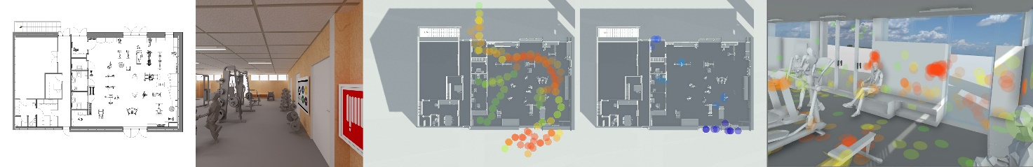
Figure 1 - An example of a VSR case study building with its plandrawing, a render from the VR walkthrough, and the heatmapping of eg. movement (green-red) and collisions (blue) in plan-view and lastly the recorded VSR gazetracking seen in the 3d model view.
Testing of the initial set-up was in addition performed as comparative study between a real space in reality, the virtual reality twin of the space, and eventually plan and section drawings of that same space. The findings from that particular study made it obvious that the overall divergence from the perception of the physical space was much higher in the plan and section scenario than when perceiving the space using virtual reality. The combination of eye tracking with user interviews of the space allowed to investigate different aspects of the perception of space. Both rigid qualities, such as estimated dimensions of the space, and also soft qualities about lighting and sensations of well-being in the space, could be compiled. The comparative question to investigate was, where people were looking for information in respectively reality, virtual reality, and on plan and section drawings, in order to answer specific questions about the architectural space. We could hence compare both their actual answers about dimensions and well-being, but also compare the less conscious act of where they were looking for the information to the answers. In short: for our group of test persons virtual reality overall came closer to the perception of reality than plan and section drawings.
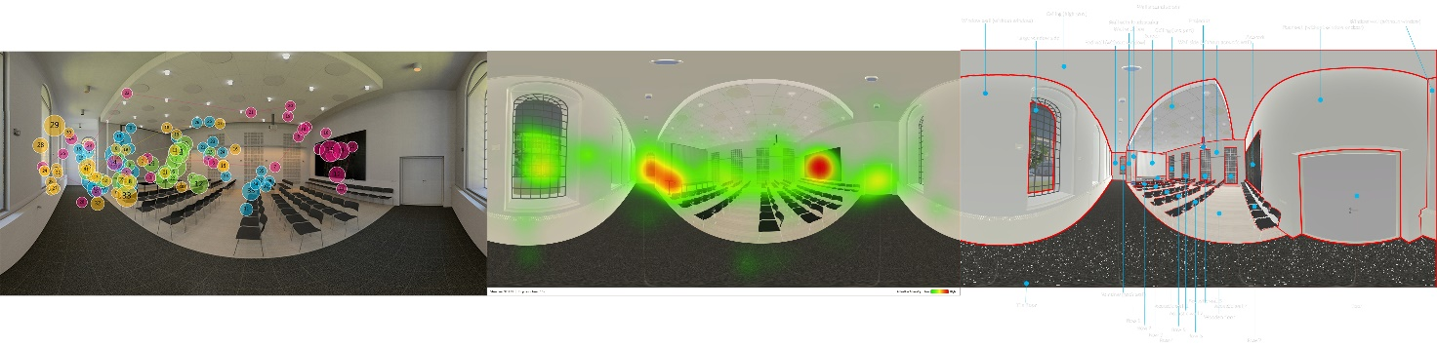
Figure 2 – Example of the eyetracking data being mapped to a 360 image of a test space and converted into a heat map showing the response to each question tested. The right image is a more detailed mapping based on the eye tracking heat map information.
Since the test persons in the study were all students in the beginning of the architecture study, selected on purpose to find people without a long architectural education or experience, we also did a cross check using the same test set-up with a small group of professional architects. The indications from this showed, as expected, that professional architects were much better to decode the drawings than first year students. Since much of the communication of an architectural project, whether transformation of existing designs or designing from scratch, involves users or builders with little prior architectural education, one of the intentions of the VSR system is to be more inclusive and opening up for dialogue of architectural space. Introducing neuro scanning as method of capturing behavioural aspects of the test persons experience became the next step in the attempt to generate feedback that was not based solely on the verbalized comments from the users. Combining the already existing virtual reality model in a game engine with light weight EEG brainwave recorder allowed a pilot test of selected performance metrics such as excitement, valence, engagement while experiencing the virtual space.
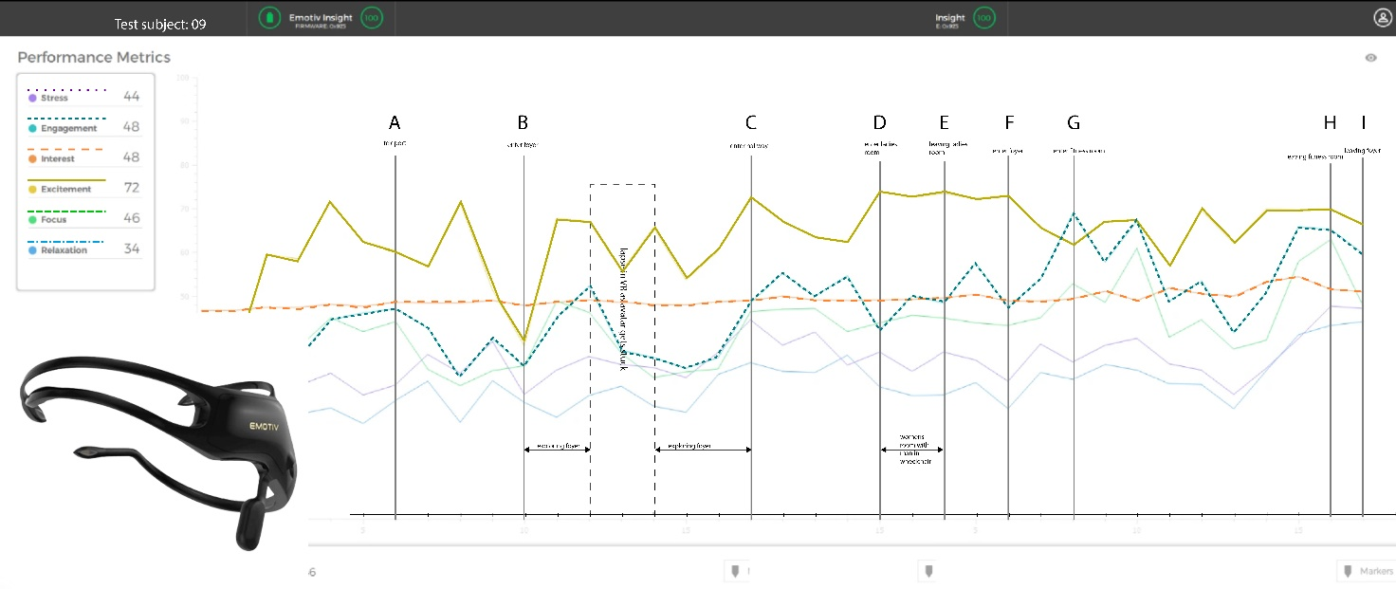
Figure 3 – Example of performance metrics from the lightweight brain scanner. The graphs show the fluctuations in the different measures and our preliminary attempt to analyse and map the occurrences from the experience with these metrics.
While the pilot study was performed with a small number of test persons, we were aware that we did not have sufficient data for a meaningful quantitative analysis and had to cautiously limit the conclusions to what we could observe individually with each test person. The performance metrics of the eight test subjects were difficult to compare since everybody reacts differently to stimuli. One person might find it interesting to e.g. get lost in the model, while another might find this very stressful. We could use this pilot test as an indication of the feasibility of the method with a larger sample size. It also suggested that we incorporate interactions in the model to achieve immersion, since interactions, i.e. with opening of doors, showed engagement in the behaviour of test persons. Since we are architects, and not neuroscientists, we also learned that a larger study, involving more precise equipment, would necessitate close collaboration with neuroscientists or neuropsychologist to extract and investigate the higher level of detailed feedback from the measurements. In a larger study undertaken with respect to some of the insights and realizations from the pilot study, we decided to build basic behavioural tracking inside the VSR as part of the game engine mechanics. This study included the automatic tracking of user location, user gaze tracking and collision tracking. The gaze tracking (i.e. the midpoint of the direction of the field of view) substitutes actual eye tracking, since the precision for overall perception of architectural space is considered sufficient. In addition, this makes the eventual equipment much cheaper and makes implementation in the building industry more likely. In this way we can streamline our methodology into a lean version based on the location, gaze, collision data obtained automatically, and the questionnaire data from user interviews. In the VSR, location data can be cross‐referenced with both the gaze- and collision maps data and the questionnaire in order to evaluate the type of the experience, at any given location the user has occupied. This feedback mechanism can sustain a spatial analysis of potential reasons to a specific type of experience. It could provide insights into what kinds of architectural cues result in pleasant and emancipatory experiences, and what cues result in frustration or confusion.
The VSR tool, though still a prototype, has since been used in architectural projects to generate reports that could send easy feedback to the architects about the sensation of the spaces. In virtual reality, the user can also see the architectural space from another person’s point of view. That could be from people with mobility impairments or visual impairments. It can also be the eye height of a child if the architectural project is for instance a kindergarten. We have made reports from the wheelchair perspective, in relation to universal design, and general comments from walking persons. The VSR tool is now capable of using digital models in virtual reality and record the experience of the users. The test persons field of view and verbal comments are recorded into a movie file along with heat maps on plan drawings of the space that show both position and collisions. In the digital 3d environment all the gaze point heat maps are likewise recorded and can be extracted on 360 images or viewed within the virtual model. Even though The VSR prototype is not aiming to be a photorealistic representation, we have made it open to customization of materials, backgrounds and made it possible to insert detailed renders, in areas where an architect would require more detailed visual feedback. It is also possible to simulate other kinds of interactive scenes such as a fire scenario with smoke accumulation. There can be inserted different models in the same viewer i.e. a laser scanning of the existing building to compare a new transformation project to the existing space. The reports generated so far in the context of building and transformation of training facilities “Fitness for All”, have all inflicted actual change in the architecture in the case projects.
All the above-mentioned methods and technologies from affective computing to quantifying the temporal experience and the application of game engines with behavioural feedback mechanisms has led us to the formulation of a next experiment combining neurology and the experience of architectural space in a collaboration with neuroscientists. This next step allows us to further refine the VSR into a tool that can assist the process of architectural design and transformation.

A next phase neurological experiment
During the process of writing this article, our neurological study has been going in a parallel track. This next section provides the initial findings on how to investigate the importance of the level of detail in the virtual reality VSR system. We consider this study highly relevant for a transformation context with an availability of and potential requirements of access to comprehensive material properties in the architectural representation.
The pilot study proposal ‘Understanding the emotional and cognitive response in VR vs. reality’ involves capturing emotional and cognitive responses on a walkthrough of architectural space with presumable different architectural atmosphere. The study was performed in a real-life space and in virtual reality models of the same space. In this study, we had three different levels of detail in the virtual reality model (Figure 4). The low detail level geometrical model, a high detail textured model, and a digital scan of the architectural space. What we have been mainly using until now in the VSR is a geometrical relatively low detail model, which can be compared to the white cardboard box model architects traditionally have been using to convey architectural vision to colleagues and the public. The argument for this has previously been, that the level of detail in an early sketching phase of architectural design, contains information of geometry but very little information of materials and textures.
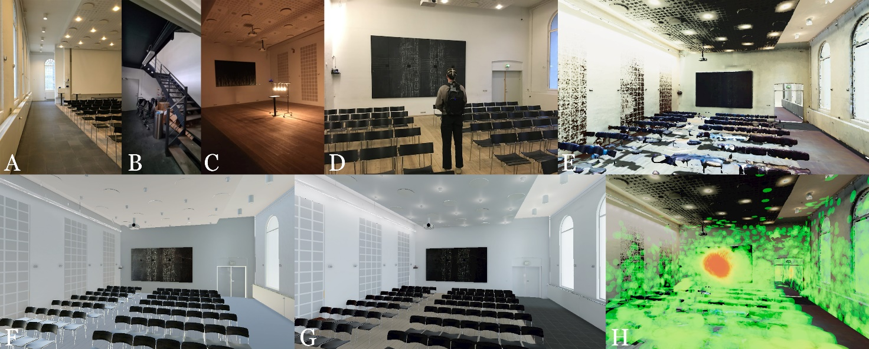
Figure 4 – The real-life situation of walking though spaces with different architectural atmosphere (A) an auditorium in daylight, (B) the stairway passage room, (C) an auditorium with a special lighting set-up). (D) shows a test subject wearing the neuro-scanner while commenting on the painting in the real-life scenario. (E) a screenshot the quality of the laser scanned model of the test space. (F) shows the low-detailed VR version and (G) the high-detailed model of the test space. (H) shows the laser scanned model with a recorded gaze tracking heat map shown.
The VSR system collects feedback from the experience of the overall architectural space, and too many details in the virtual reality model can then be confusing, since they are not yet decided by the architects, and will draw too much focus and attention from the overall experience of the dimensions and proportions of space. That has deliberately made us apply a model with no textures and very little colour. However, some projects require specific considerations to selection of materials or atmospheres, which is why the VSR has the option to insert detailed areas in a controlled manner, to get specific feedback. In an architectural transformation project, where an existing framework exists, it is possible to make a digital scan of the existing space and combine the visual representation of existing materiality with the transformative suggestions. The different approaches to the representational architectural model supposedly have a connection to the neurological perception of geometry and surface, as mentioned in the background chapter of the essay. But how can we find the right level of detail required to convey an architectural vision, idea, and atmosphere? We are interested in understanding whether people can have the same emotional and cognitive experiences in virtual reality as in real life. The purpose of the study is to understand more about how virtual reality can be a new effective solution within architecture and design to drive a more efficient process with higher architectural quality. At the same time as testing whether VR and real life drive similar responses, we are also interested in understanding if the quality of the virtual experience has an impact on the way people respond emotionally and cognitively. By using three different levels of detail in the virtual reality model and compare this to the real-life experience, we will be able to understand a broad spectrum of experiences within the architectural space. In collaboration with Neurons Inc’s NeuroLab and EEG procedures, we can understand the emotional and cognitive experience second by second within different qualities of VR and in the real-life experience. In this study, 40 participants from Denmark were invited to take part in either the real-life experience or the virtual experiences. One of the main necessities of the study is to measure to what extent the cognitive and emotional response is comparable from the real-life experience to the variety of virtual experiences. So, the idea is to have three different main architectural experiences on the walkthrough. We began the study by entering an auditorium with an everyday atmosphere and standard electrical lighting. The test persons then continued through a storage area with more confined proportions and less lighting, and eventually arriving in a auditorium similar to the first one, but his time with different lighting conditions, coming from a few very warm yellow coloured bulbs. During the walkthrough there were small tasks to perform in the different locations, in order to present uniform stimuli to measure the emotional and cognitive impact. These included simple counting of windows or cups in the room, a short reading exercise in each room, and an aesthetic contemplative task commenting on a large painting in the two auditoriums. This was to broaden the spectrum of neuro-stimuli to be successively analysed. During the experience, some questions were also asked to the participant to get stated preferences and feelings. Finally, the participant walked through a post survey to capture additional answers to the experiences. The results from the study are still subject to our analysis, but we can already see that both VR settings high and low detail elicit similar experience to real life, while the laser scanned VR model does not (Figure 5 top). The laser scan is capturing everything with no discrepancy or hierarchy of architectural importance. And at the same time the model appears crude and with strange geometry and holes where the laser could not reach exactly.
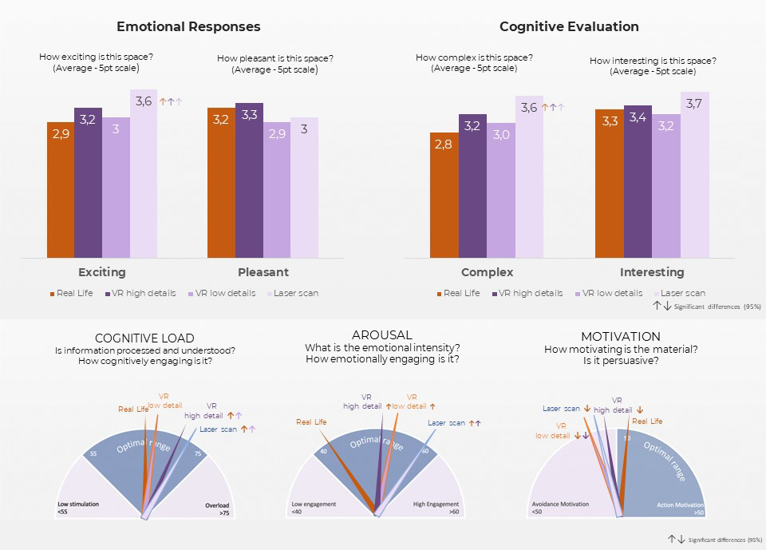
Figure 5 – (top) VR setting (except the laser scanning) elicit a similar experience to real life. (bottom) Cognitive load, Arousal, and Motivation throughout the whole experience of the four types of architectural atmosphere in real life, VR high detail, VR low detail, and laser scan.
This combination of crudeness and capturing many details, but perhaps the wrong and too many details, can be part of an answer to why the laser scan is the least similar to the real-life situation.
These results are already providing insights into whether people have similar emotional responses in the real experience compared to the virtual experiences. We can measure if people have similar cognitive responses in the real experience compared to the virtual, and also how the quality and level of detail of the virtual experience have an impact on these responses. From the preliminary analysis of the findings, it is also possible to see that, in general, real life performs better than all the VR setting on neurometrics (Figure 5 bottom). The potential of cognitive overload is highest in the laser scan model, while the motivation, the persuasiveness of the different tasks and the overall experience are lowest in the low detail and the laser scan model. As this is a general picture, we will of course dive into further analysis of the different tasks that shows a more detailed perspectives when looking at the difference between i.e., reading a text and contemplating a piece of art.
Finally, the collected data of statements from people experiencing the real experience compared to the virtual experience assists in analysing how they perform similar tasks in the different experiences, and these differences affect the performance. In this recently concluded study we have collected a lot of data, that will need to be put into context. I am looking forward to the further dissemination of the findings in future publications.

Conclusion and discussion
This essay has hopefully been able to provide a sufficient frame of reference for a discussion about the applied use of virtual media as a media for architectural design and transformation. The implications of using a methodology that aims mainly at the human visual perception has been attempted seen in the light of neurological perspectives of how the brain generates models of the world based on stimuli and previous experiences. This is by no means an easy discussion, and I am not trying to oversimplify the complex and multidisciplinary use of representational models in architecture. This should rather be seen as an attempt to critically embrace the newest technology and cognitive insights to expand the potential of architectural representation. The representations of architecture are manifold in each architectural case. It might be relevant to pose the question of what kind of representation, or combination of representations, might convey the idea of the project in the best way. Obviously, architectural projects today are represented through a combination of media ranging from plan, section and façade drawings to physical models, digital renderings & models, and written textual descriptions or specifications. All of these are valid forms of representation with their own limitations and in their own respect. Let us embrace the implications of new media, such as virtual reality, and the possibilities that can be derived from studying and applying these techniques being aware that any form of representation is to some extent a reduction of the actual project. I do not believe that new technology, and in this context the VSR’s virtual logging mechanism, can stand alone as a meaningful representation of architecture. But I simply suggest that architectural projects should also actively investigate the possibilities of any new technology, and pay attention to the development of cognitive neuroscience, to implement all these new findings about perception into the work with architecture and the phenomenology of shaping our houses, cities, and landscapes. Every technology, from producing cardboard models to simulating the potential use of a building in virtual reality, should be applied where it is working, and not as a general principle that cannot be deviated from. By wanting (and having) this discussion, I hope, in addition to avoiding the oversimplification of the subject with a tendentious debate of simply ‘digital versus analogue’, to be able to discern the complexity of different (digital) working methods. These digital working methods and tools are now so numerous that they need and should be differentiated correctly. A way of doing so, could very well entail the application of neurology and the understanding of how the human mind works when perceiving the world that surrounds, and penetrates us. A digital 3d ‘virtual’ model seen on a computer screen is not the same as a virtual reality model experienced in a head mounted display. As is a drawing not the same as a model, and a text is not the same as a photo. And none of the above mentioned is equal to the actual real transformed building or created architecture. But it can potentially all sustain the feeling or atmosphere of the right architectural quality, if applied correctly. I believe that awareness of what technology can do, and where this specific virtual technology can do its best, is key to improving the significance and quality of using architectural representation as a working method within both design and transformation of architecture. So let us repeal the old-fashioned debate of the analogue versus the digital and include all means of architectural representation in our attempt to better understand how we can create architecture that works.

Juhani Pallasmaa, The Eyes of the Skin : Architecture and the Senses (Chichester; Hoboken, NJ: Wiley-Academy ; John Wiley & Sons, 2005), p. 64.
Maurice Merleau-Ponty, The Structure of Behavior, The Structure of Behavior. (Oxford, England: Beacon, 1963). Chapter IV. The Relations of the Soul and the Body and the Problem of Perceptual Consciousness, pp. 185.
Maurice Merleau-Ponty, Phenomenology of Perception (London; New York: Routledge, 1962), p. 273.
Pallasmaa, The Eyes of the Skin : Architecture and the Senses. Part 2, pp. 39.
Semir Zeki, Inner Vision: An Exploration of Art and the Brain (USA: Oxford University Press Inc., New York, 1999).
Semir Zeki, ‘The Disunity of Consciousness’, in Progress in Brain Research, ed. Rahul Banerjee and Bikas K. Chakrabarti, vol. 168 (Elsevier, 2007), 11–268, https://doi.org/10.1016/S0079-6123(07)68002-9.
Harry Francis Mallgrave, The Architect’s Brain: Neuroscience, Creativity, and Architecture (John Wiley & Sons, 2010), p. 135.
Sarah Williams Goldhagen, Welcome to Your World : How the Built Environment Shapes Our Lives, First edition. (New York, NY: Harper, an imprint of HarperCollinsPublishers, 2017), p. 154.
Jon Lauring and Nicolai Rostrup, An Introduction to Neuroaesthetics: The Neuroscientific Approach to Aesthetic Experience, Artistic Creativity, and Arts Appreciation, ed. Jon Lauring (Copenhagen, Denmark: Museum Tusculanum Press, 2015), p. 201.
Jacob Grobman and Avishag Shemesh, Space and Human Perception – Exploring Our Reaction to Different Geometries of Spaces, 2015.
Avishag Shemesh et al., ‘A Neurocognitive Study of the Emotional Impact of Geometrical Criteria of Architectural Space’, Architectural Science Review 64, no. 4 (4 July 2021): 394–407, https://doi.org/10.1080/00038628.2021.1940827.
Goldhagen, Welcome to Your World : How the Built Environment Shapes Our Lives, pp. 148-157.
I. Biederman, ‘Recognizing Depth-Rotated Objects: A Review of Recent Research and Theory’, Spat Vis 13, no. 2–3 (2000): 241–53, https://doi.org/10.1163/156856800741063.
Goldhagen, Welcome to Your World : How the Built Environment Shapes Our Lives, pp. 160-63.
Kay Young and Jeffrey L. Saver, ‘The Neurology of Narrative’, SubStance 30, no. 1/2 (2001): 72–84, https://doi.org/10.2307/3685505.
Ann Sussman and Justin Hollander, Cognitive Architecture: Designing for How We Respond to the Built Environment (USA: Routledge, 2015), https://doi.org/10.4324/9781003031543.
Eric R. Kandel, Principles of Neural Science, 2013, p. 577.
Laura U. Marks, The Skin of the Film : Intercultural Cinema, Embodiment, and the Senses (Durham; London: Duke University Press, 2000), pp. 162-.
Mel Slater et al., ‘How We Experience Immersive Virtual Environments: The Concept of Presence and Its Measurement’, Anuario de Psicología 40, no. 2 (2009): 193–210.
Roger N. Shepard and Jacqueline Metzler, ‘Mental Rotation of Three-Dimensional Objects’, Science 171, no. 3972 (1971): 701–3, https://doi.org/10.1126/science.171.3972.701.
Maria Kozhevnikov and Rupali P. Dhond, ‘Understanding Immersivity: Image Generation and Transformation Processes in 3D Immersive Environments’, Frontiers in Psychology 3 (received 2012): 284, https://doi.org/10.3389/fpsyg.2012.00284.
Raffaello Brondi et al., Evaluating the Impact of Highly Immersive Technologies and Natural Interaction on Player Engagement and Flow Experience in Games, vol. 9353, 2015, https://doi.org/10.1007/978-3-319-24589-8_13.
Mel Slater and Maria V Sanchez-Vives, ‘Transcending the Self in Immersive Virtual Reality’, Computer 47, no. 07 (July 2014): 24–30, https://doi.org/10.1109/MC.2014.198.
Guido Makransky, Thomas S. Terkildsen, and Richard E. Mayer, ‘Adding Immersive Virtual Reality to a Science Lab Simulation Causes More Presence but Less Learning’, Learning and Instruction 60 (1 April 2019): 225–36, https://doi.org/10.1016/j.learninstruc.2017.12.007.
Maria V. Sanchez-Vives and Mel Slater, ‘From Presence to Consciousness through Virtual Reality’, Nature Reviews Neuroscience 6 (online 2005): 332, https://doi.org/10.1038/nrn1651.
Javier Marín-Morales et al., ‘Affective Computing in Virtual Reality: Emotion Recognition from Brain and Heartbeat Dynamics Using Wearable Sensors’, Scientific Reports 8, no. 1 (12 September 2018): 13657, https://doi.org/10.1038/s41598-018-32063-4.
Javier Marín-Morales et al., Presence and Navigation: A Comparison Between the Free Exploration of a Real and a Virtual Museum, 2018, https://doi.org/10.14236/ewic/HCI2018.45.
Sayyed Amir Hossain Maghool, Marc Aurel Schnabel, and Tane Moleta, ‘A Framework for Quantifying the Temporal Visual Experience of Architecture: A Case Study of the Sheikh Lotfollah Mosque’, ed. et al Ali Ghaffarianhoseini (Imaginable Futures: Design Thinking, and the Scientific Method. 54th International Conference of the Architectural Science Association 2020, New Zealand: Architectural Science Association (ANZAScA), 2020), pp. 91–100.
Stefan Mayer and Jan R. Landwehr, ‘Quantifying Visual Aesthetics Based on Processing Fluency Theory: Four Algorithmic Measures for Antecedents of Aesthetic Preferences’, Psychology of Aesthetics, Creativity, and the Arts 12, no. 4 (2018): 399–431, https://doi.org/10.1037/aca0000187.
Anders Hermund, ‘Human Computer Interacting Through a Game Engine: Qualifying Inclusive Design in Architecture’, ed. Masaaki Kurosu (Human-Computer Interaction. Theory, Methods and Tools, Cham: Springer International Publishing, 2021), pp. 30–49.
Anders Hermund and Lars Simon Klint, ‘Virtual and Physical Architectural Atmosphere’, in NZAAR International Event Series on Natural and Built Environment, Cities, Sustainability and Advanced Engineering (Proceedings of the International Conference on Architecture, Landscape and Built Environment (ICALBE 2016), Kuala Lumpur, Malaysia, Kuala Lumpur, Malaysia: New Zealand Academy of Applied Research Ltd, 2016), 3–4.
Anders Hermund, Ture Slot Bundgaard, and Lars Klint, ‘The Perception of Architectural Space in Reality, in Virtual Reality, and through Plan and Section Drawings: A Case Study of the Perception of Architectural Atmosphere’, ed. & S. Bialkowski (red.) A. Kepczynska-Walczak, 36th ed., vol. 36, Computing for a Better Tomorrow: ECAADe 2018 (Computing for a better tomorrow: eCAADe 2018, Poland, 2018), 10.
Anders Hermund, Morten Myrup Jensen, and Lars Klint, ‘The Neurological Impact of Perception of Architectural Space in Virtual Reality’, in Virtually Real -7th ECAADe Regional International Symposium (7th eCAADe Regional International Symposium, Aalborg University, Aalborg, Denmark: eCAADe Regional International Symposium, 2019).
Anders Hermund, Lars Klint, and Ture Slot Bundgaard, ‘Neurological Feedback from Perception of Architecture in Virtual Reality: A Methodology Study’, 2019.
Anders Hermund, Lars Klint, and Ture Slot Bundgård, ‘Bedre Inkluderende Arkitektur: Med Nyt Værktøj i Virtual Reality’, Handicap NYT, no. 1 (2020): 40.
Kasper Rander, ‘Realdania: Fitness Skal Være for Alle: Tre Projekter Nytænker Fitnesscentre’, 2017, https://realdania.dk/nyheder/2017/11/fitness-skal-v%C3%A6re-for-alle_09nov2017.
Neurons Inc. - www.neuronsinc.com

