Paper for The Nordic Association of Architectural Research Symposium:
The Production of Knowledge in Architecture by Ph.D. Research in the Nordic Countries

Anders Kruse Aagaard
Ph.D.- Fellow
Aarhus School of Architecture

Bespoke Fragments: Experiment and experience-driven knowledge production

Keywords: digital fabrication; materials; experiments; experience; virtual; actual; control; uncertainty;

Abstract
The Ph.D. -project Bespoke Fragments seeks to explore and utilise the space emerging between the potentials of digital drawing and fabrication and the field of materials and their properties and capacities. Within this span, the project is situated in a shuttling between the virtual and the actual, investigating levels of control and uncertainty encountering with these.
Through tangible experiments, the project discusses materiality and digitally controlled fabrications tools as direct expansions of the architect's digital drawing and workflow. The project sees this expansion as an opportunity to connect the digital environment with the reality of materials – and use realisation and materialisation to generate architectural developments and findings through an iterative mode of thinking about the dialogue between drawing, materials and fabrication.
The control of fabrication tools through digital drawing opens up a new approach to materials in an architectural context. The knowledge and intention of the drawing become specialised through the understanding of the fabrication processes and their effect on materials. When drawing embeds not form, but capacity, into the material through fabrication, the emergence of virtual space is no longer limited to the computer's digital world, but extends into the materials' world. Creation and uncertainty are allowed as virtual parameters in both the digital and reality. Based on this notion the project suggests utilising that exact potential to develop architectural designs, tectonics and aesthetics.
In this Ph.D.-project a series a physical, but conceptual, experiment plays the central role in the knowledge production. The experiments result in materialised architectural fragments and tangible experiences. However, these creations also become the driving forces to discuss, link and develop theoretical understandings around the project’s intention and production.

Perspective on experiments

Drawing into materials
A furious development in both computer-aided drawing and designing software and digital fabrication tools are changing the interface between representation and realisation. Digital drawing and designing software have long been well-implemented instruments in the production of architectural ideas and architecture. They often play a vital role in the combined process, including sketching, development and realisation.
This well-implemented and substantial group of tools is going through never-ending development that continually brings new possibilities and strengths to the hands of the architects. The interface that has aroused between architect and computer has opened up new ways and powers for handling, processing, converting and sharing data and has in many respects changed the ways architects work, but also directly how architecture appears. (Callicott, 2001; McCullough, 1996)
Among other things, the software tools are gaining wider abilities and closer relationship to those interfaces used in manufacturing and fabrication. Ways of production are, at the same time, getting easier and easier to access for people not involved in industrial manufacturing.
Technologies that incorporate digital fabrication units have been getting cheaper and more accessible. They are now present from consumer to manufacturer level and everywhere in between. Today it requires no more than a laptop, a 3D printer and very basic computer knowledge to start up a digital fabrication workflow. Fabrication technology is intermixing with designing on user level and therefore already changing the tools we have at hand. However, the current development not only means a downscaling of industry machinery to plug-n-play user level. The possibilities and course are multi-directional. Integration of soft- and hardware creates similar possibilities for stepping up and moving from designing into an industry-grade production. Digital drawing software can be used to instruct the machines to move, orientate and process. In industry, these machines process real materials with high precision. What they do is not new. They do parts and component used in a variety of industries and production. How they are controlled, however, and how easily they are controlled, creates the foundation for a new tight connection between the world of digital drawing and digital fabrication(Sheil, 2005).
Architects can utilise this connection between digital drawing and digital fabrication to engage directly with materials. Direct intervention with, and continuous feedback from, materials allow architects to explore them in new ways in relation to architectural production. New material possibilities create a foundation for the discovery of new aesthetics, tectonics and constructions. It is the claim that this fused space of digital and reality, immateriality and materiality, can allow architects to access and unfold options and opportunities for design. The correlation between digital drawing and materials through fabrication can establish an unbroken link between early experimentation, design and component development and potential final fabrication.

The act of experimenting
The project Bespoke Fragment is built around experiments, the act of experimenting, but also the discussion of experiment and experimenting in the context of architecture and architectural research. Experimentation as a word or action is at ease in the context of architecture. Being experimental or conducting an experiment seems like a familiar and acclimatised concept as a part of producing architectural design. Not that it might be a necessity in order the to build something, but, without generalising too much, one could assert that variants of experimentation are either demanded or taught in most architectural educations as well as the behaviour of ‘being experimental’ is something many practices are utilising as a working method in order to create innovatory ideas.
Within scientific research experiment is, as well, a very well established way of gaining knowledge. Often has experimental methods been articulated as equivalent to scientific method. An experimental strategy can take many forms, but in all situations is the act of experimenting and setting up an experiment a construction to engage a present actuality.
The experimental method has not traditionally dominated architectural research. This is despite the immediate obvious link between architectural working methods and other, more, established research profession. Architectural research has more traditionally been concerned with historical or analytic topics and less about involving experimental laboratory work.
Experiments play a central role in this Ph.D. project. The general reason for this can be explained by the ability of the experiment to reach out and engage with the real world. This articulation is, however, quite overall and it will need further unravelling of the use and perspective on experiments to be elucidated.
First, the use of experiment in general and in connection with architecture and building might need to be shed some light on.
The relationship and the hierarchy between theory and experiment seem to be an ongoing, turbulent affair. Through the history of science, the highest acceptance and appreciation of the one or the other appears to be a, if not shifting, never finalised discussion.
Nicolaus Copernicus and Galileo Galilei are often noted as the founders of methodical experimental approach to science, physics and nature and Isaac Newton as the formalising force of this methodology. The founding and formalisation of this type of scientific work were based on a combination of observations and mathematical description of those. The approach was calling for an inductive-deductive strategy. General, mathematical or theoretical descriptions or explanations were made from large quantities of observations. These descriptions then functioned as a structure for a deductive, general understanding of the properties and behaviours of objects in nature (Kotnik, 2011, p. 27). This experimental approach allowed observations of actual viewable or readable behaviours of existing, performing phenomena to be the basis for a universal thinking that then again could be tested on specific observations.
Looking at architecture and building the use of an inductive-deductive experimental method is has proven a valid strategy, but also a limiting strategy. Good examples of the use of the experimental method as a controlling design principle are found in the works of Antoni Gaudi and Frei Otto. Gaudi’s hanging chain model is an excellent example of how a specific experimental method is used to identify correlations, derive design principles and use those for building construction (Huerta, 2006, p. 331). Similar are Frei Otto’s study and descriptions of his tent like soap structures an observation-based research strategy that leads to mathematical descriptions of optimised geometry. His deductions opened a world of construction types probably not imaginable without the prior experimentation. Frei Otto himself has strongly advocated for the use of experimental research as an essential path for architectural development (Songel and Otto, 2010). However, Otto also acknowledges fundamental problems with his integration of scientific experimentation in architectural practice. While being able to extract form and optimised geometry from his physical testings, he argued that this as a design work was not comparable to that of a building project. Buildings are not individualities but integrate into surroundings and society. This statement is advanced by Toni Kotnik (2011, p. 29) and explained by the fact that in a scientific-experimental arrangement the number of possible determining parameters must be reduced. This is needed to focus and target the experiment on the phenomenon in question, but naturally also only give an equivalent focused set of result. The nature of scientific experiments can thereby limit the design space dramatically if architectural work is carried out only on the basis of this. In cases where the experimental output meaningful dictates the governing design principle this might not be problematic, but nonetheless eliminates the possibility of a general direct translation from experiment output to design concept.
Throughout the Ph.D-project experiments based on material exploration is carried out. The processing of materials is a driving action in the research production. However, parallel with the material revelations the behaviour and role of the experiments seen from a design methodological perspective are attempted discussed. It is by default not the intention to directly translate material output to architectural suggestions or dreams – even though this is a possibility. The act of the material experimentation as a design tool is, in itself, a case for inductive reasoning. A notable gaining from both the material output and the act of experimenting is experience. Experiential knowledge is a result of continuous experimentation, but also, traditionally, what causes the friction with theoretical knowledge. Experience is, naturally, anchored in its origin, thereby not in itself an autonomous type of knowledge. Since this, aforementioned, discussion of hierarchy is a mainly scientific-philosophical matter it is not the intention to unravel it here. Instead, this project takes advantage of the character of experiential knowledge gained by experimentation. Because the experiential knowledge is directly connected to whatever process and material it is gained from it constitutes an action into reality and an extraction of information back to the intention from where it came. An amassing of this information is the setting for experience and thereby a possible induction of principles – still with an unbroken link to realities.
When an experiment is established and carried out, information from its experimental framework is feeding it and an opposite stream of consequence-based information feeding back. This information would under a more traditional scientific-experimental circumstance be the resulting data from which induction reasoning could be made to create a more general assumption. As referred to earlier this might be problematic seen with the perspective of bringing it into architectural design. Moreover, this is the point where the intention of using experimentation within this research project can be unfolded. The material experimentation in this project is not triggered by the eagerness to create general material-physic assumptions – for that the data quantity is too small. Likewise, it is not the primary expectation to invent new material systems or types of processing – even though this is a very welcome by-product. The aim of experimenting directly in materials is instead revolving around the possibilities arising when an inquisitive design intent navigates the experimental course. Therefore, the decisions and the point of decisions making made throughout the experiment becomes of interest. In that way, the unfolding of an experiment can be seen parallel to the development of a design and the actions made within the experiment crucial for the outcome.

Materials and Machining
The project has established an experimental framework that consists of materials and machining approaches. This framework is during the project regarded as a quite dogmatic core throughout the entire project. Every experimental setup is insisting on establishing a discussion that includes ingredients from the framework – but can add externally found elements if this makes sense. The experimental framework is created to have a very tangible frame from where more intangible though and arrangement can be tested. These more speculative constellations are originating and continuously born through the unfolding of the project’s intention and queries of interest. The framework is also a way to anchor the entire project within its intended context. The project is aiming at being relevant for the practice and profession of architecture, and thereby committed to production and discussion that are linked to these.
The framework involves three materials and four types of processing. The materials are concrete, wood and steel. The processes are division, subtraction, addition and transformation.

Processes of machining
The processes are all linked, but not limited, to different types of machines or construction strategies. This is to ensure that they can function as straightforward and actives way of engaging materials and not only as conceptual labels.
The act of dividing is fetched from machines that cut. Those can be laser cutters, knife cutters, hot wire cutters, water jet cutters, etc. Subtraction is taken directly from the type of machining done when milling or routing. Additive manufacturing is generally known from the 3D printing industry, but due to the material narrowing down of this project not limited to this. Instead, addition is looked upon on a more general level involving all types of posing and composing of the materials. Transformation is referring to any action that changes an amount of material from one condition to another. This can be related to a state, form or anything else, but is distinguishing itself from the others by not interfering with the amount of material but instead the circumstances or distribution of the material. The four types of processing are not set up as a limit of interaction – other possible processes can join in interplay with them. Likewise, the processes can be combined in the experiments.

Properties and capacities
The materials – concrete, wood and steel – are selected because of their different characteristics and because of their direct relevance and connection to building and thereby to architecture. They are not novelties themselves, but they represent an assortment of materials that both is bound to long traditions of working, machining and tooling and at the same time still very present and prevailing in contemporary buildings. All of the three materials can be found in almost any building today and are impossible to ignore, no matter what agenda one might have, in the context of building construction.
The materials chosen are also rather different in the state in which they are usually processed.
Concrete is, when looked on at a larger scale,, an isotropic material. It is fluid for a limited period of time in which it can be given a shape, then cures hard as stone. The fluid state makes it not only possible to shape the material on the basis of other thing, but also to combine other things or materials into the mix.
Wood is a naturally grown material that comes from an almost infinite number of species each with specific characteristics. A general characteristic for wood is fibre directionality. The grains in the wood make it an anisotropic material that will respond differently to machining depending on the orientation of material and/or tool. The machining of wood is also dependents of the moisture content of the material. That will vary from species to species and be a result of the amount and type of storage prior to the machining. Due to following drying, wood will generally change shape or crack after machining.
Steel can be shaped from its fluid or solid state. To cast fluid steel it will need to be heated intensely in a forge. The shaping of solid steel can be done using several machining types. In its solid state steel is isotropic but often limited by industry standards to specific dimensions, geometries or sheet thicknesses. Often, parts constructed in steel will either bear references of prior given geometries or be flat surface dominated. Parts routed from a single steel block will have uniform material appearance with tool imprints defining the surface.
As outlined here the combined range material characteristics give a good base for different types of experimental exploration. The behaviour of the materials in relation to the processing of them is of great interest and seen as a starting point for making discoveries. The encounter of materials and tool will result in a consequence related to both. To clarify these occurrences and thereby the experiments a look and differentiation between material properties and material capacities are made. Material properties are defined as objective characteristics that can be listed. Capacities, on the other hand, are relational. A capacity to affect always goes with a capacity to be affected (Aagaard, 2015; Delanda, 2007).
The distinguishing between properties and capacities is crucial to determine the sequence of event that occurs when material experiments are established and gives a valuable perspective about decision-making during experimentation. Of course, any machining applied to a material will directly encounter whatever properties the material is holding. A well-matching combination of machining type and materials will likely give a controllable experiment, maybe even predictable, whereas a non-matching combination might be totally out of control, maybe even result in physical damage. It is in-between these extremes of material consequences that the experimentation is intended to be carried out.

Setting up the experiments
To implement material research and material experiments as a part of the earliest architectural design phases an open minded non-deterministic approach to the material investigations are required (Kolarevic, 2008). Discoveries made by studying and exploring materials through machining can be of a highly unpredictable character and lead to many surprises. These surprising outcomes of the encounter of machining and material properties should be considered qualities in the phase of exploring form and design as well as an opportunity to let further investigations shed light on the relations between certain machining techniques and certain material properties or capacities.
To position materials as an essential experimental way of discovering and initiate design it seems natural to move the existence of machining and material from the end-result oriented construction or manufacturing phase to an early more inquiring phase of architectural design. Results of material experiments made with an investigative objective will contain a type of knowledge that is tangible, but not primarily technical. The outcome will not be a realisation of a design, but instead hold the potential of initiating a design or facilitate the beginning of further research (Aagaard, 2015).
A combination of this described material-experiment agenda and the experimental framework sets the basis for every experiment carried out in this project. The drawing is regarded an instrument to embed information into the materials through fabrication, in that way altering the capacities of the materials on the basis of their properties. It is when new material capacities are created that findings and revelations unknown prior to materialisation are believe to surface.

Navigating (within) the experiments
Within the possibilities given by the experiments a constant interaction or decision-making is required to both search for and intercept encounters with architectural or spatial interest. The framework gives numerous combinations of materials and machining and the intention of exploring the materials is demanding for a non-deterministic approach that relaxes the level of control. The machining is seen as an expansion of the drawing thereby moving the structure of architectural sketching and designing from a mainly representational domain and into a realising domain.
Through the execution of experiments a kind of Cartesian system of orientation has been created. The system establishes as experimental field by uniting two spans. One span is defined by the extremes of virtual and actual and the other by the extremes of control and uncertainty. Experiments are seen and conducted as being moving and living within this field during their execution. The system is both a result of the experiences carried out through the entire project and a methodological tool in order to navigate within and across the experiments. The development of the experiment has created the system and the system has created the experiments simultaneously. The articulation of the system has taken it from a subjacent, implied existence to an applicable tool.

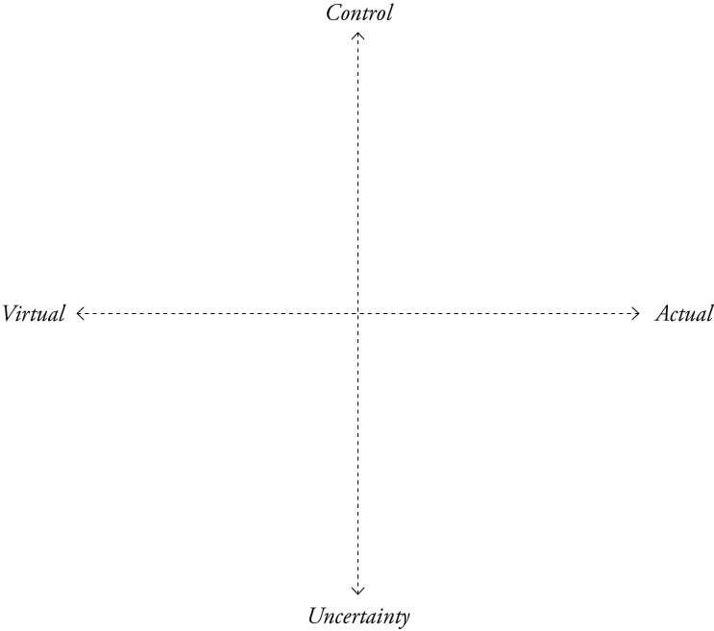

To understand the system the spans, or axes, need to be explained. The two extremes of control and uncertainty are describing the element of exploration or investigation required and desired in each experiment. The material exploration initiated through experimentation is in need for uncertainty or risk-taking in order to exist. This premise for finding the unknown is logical enough not to know it – therefore, a level of uncertainty plays a central as a part of the material investigations. Another premise is that of inductive reasoning. To establish a correlation between observations, an amount of systematisation is needed. Coincidence or pure luck can make discoveries, but to understand them well enough to utilise them, testing and verification are required. This means that, for example, an initiating phase of an experiment can be driven by a high level of uncertainty to find potential possibilities through the encounter of material and machining. A following phase of controlled testing can then be used to understand the findings. Control can also be the initiator of an experiment. For example, can systematic testing starting by known behaviours widen the established field of knowledge by gradually moving from a controlled situation into uncertain areas. A shuttling between control and uncertainty can, of course, be related to several aspects of an experiment. It can be the actual control of machining, how the drawing is created, the result of the meeting of material and tool or anything else. As earlier mentioned, a complete or complete lack of control might be of lesser interest than the constellation existing in-between.
The span of virtual and actual is brought to the system to discuss the underlying interest of the project through the experiments. The possibility to reach into the reality of materials through drawing can be of multifaceted use for architects, but to bring the qualities of material knowledge into a phase of architectural design where it will make an actual difference, the type of connection made between drawing and material is of importance. A connection made on the basis of a file-to-factory idea can maybe make production seamless, but do not expand the actual designing or decision making into taking advantage of either material or machining qualities. To do this, design and drawing must happen in or in very close relationship with the materials in question.
The virtual is in opposition to the actual – but the two are connected and mutual dependent. The concept of virtuality is taken from philosopher Gilles Deleuze (1991, pp. 96–98; 2002, pp. 148–150) and serves an operational role in the construction of experiments throughout this project. Deleuze’s virtuality is a potentiality that can be fulfilled in the actual. The actual does not exist alone but will always be related to virtualities that render it possible. To every action is an amount of possibilities that will always connect to this action whether materialised or not – therefore the virtual is real but not material. The Deleuzian notion of virtual is described as a surface effect produced by actual causal interactions.
The concept of virtual and actual is in this project claimed to be directly relevant in the establishing of a generative two-way connection between drawing and realisation. The virtual is a mode of possibilities and, therefore, a mode from which decisions and interactions can be made. The consequence is actual and materialised. Drawing can be a way of establishing a field of possibilities – or a domain of virtuality – from where many actions can be taken. However, virtuality should certainly not be seen a limited to drawing – or the digital for that matter – but instead pursued in realisation as well. Like with the virtuality of the digital drawing, physical existences are surrounded by virtualities. In the meeting of this drawing and these physical existences the overlapping field is believed to create new virtualities. This is, for instances, directly linked to the capacities of the materials. Capacities can be created in the materials through machining based on drawing. They might not be directly visible as consequences of the fabrication but when actuated they affect the material behaviour. Capacities are a type a material virtualities. If a workflow can be established where virtualities are available as input from both drawing and realisation, it is believed that this workflow can be used as a way to include both in architectural design.

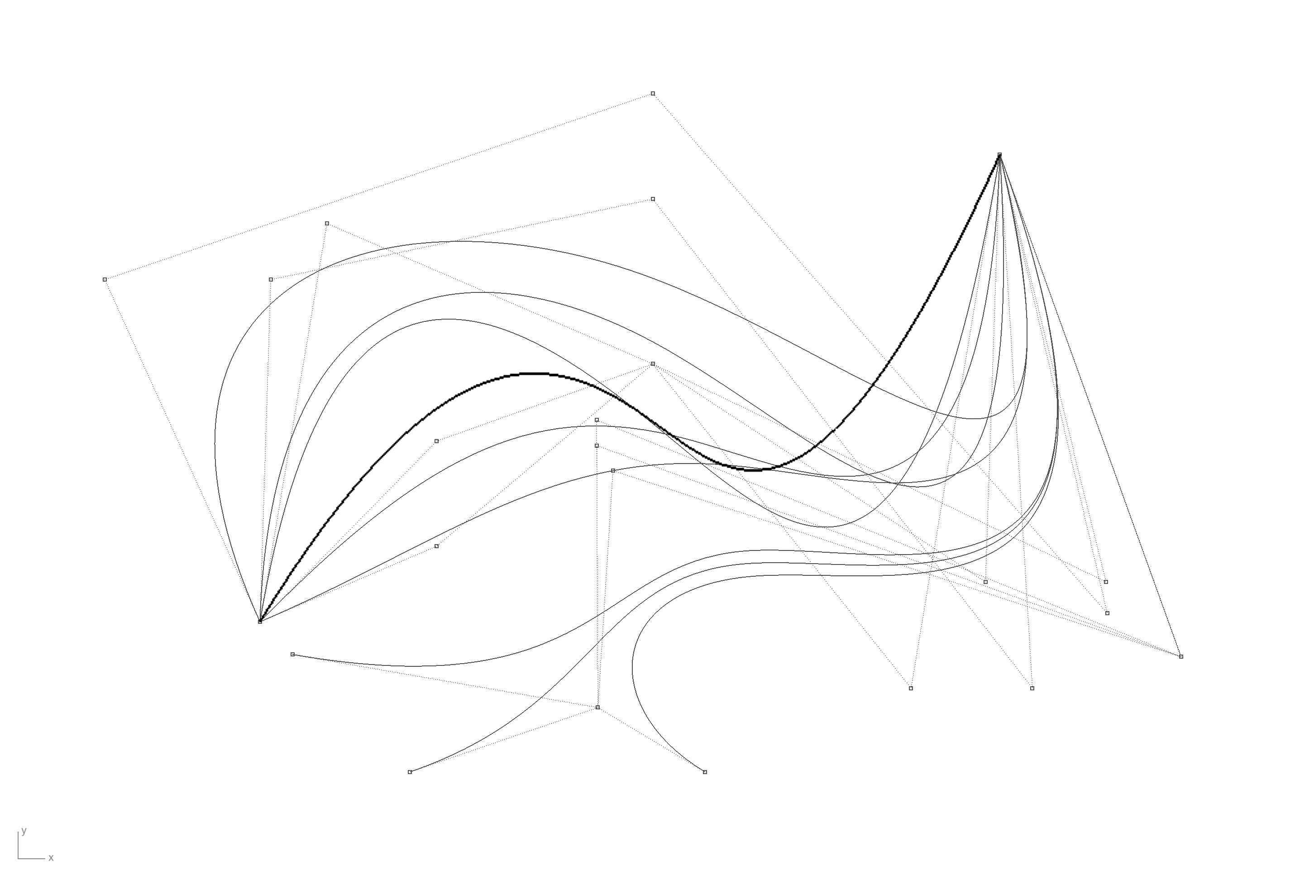

Selected experiments
To explain and exemplify how the above described experiment purpose and strategy have been carried out, a selected pair of two experiments will be presented. A total of seven different experiments has been executed through the research project. The presented two experiments are understandable not enough to clarify the full extent of the Ph.D. project, but should be sufficient to support the themes and thoughts outlined in the previous sections and give a glimpse of the physical production in the Ph.D.

EXP 1: Accumulated transformation

Intention
A fundamental premise of the entire research project is an inquisitive attitude to materials and processes. Therefore, series of physical test and investigations are carried out during the stretch of the project. This includes a high degree of un- or semi-planned experimental accomplishments without clear ambition or intention. In many cases, these are driven by curiosity and a search for consequence and surprises found in the combination of materials and processes.
While some material experiments are investigated in-depth and intense and some are left at a more developing stage, they have all started at a simple testing level. A testing can be initiated out of pure material and machining interest or from a more phenomenological or methodological point of view. They share a physical output – often of a smaller dimension – and their relation to and information about material and process. Despite their different origins they share a status of being initiators and therefore together constitute group or accumulation of knowledge.
The accumulation of smaller, connected or individual, material and machining tests is seen as a type of experiment or subproject. Unlike the other experiments in this overall project, this one has no start or end. There is no longer focus or aspiration for a greater unfolding of potentials or technics within this knowledge pool itself, but instead a desire to create a never ending, ever growing, mass of inspiration. This part of the project is being articulated as an experiment on its own so that production and findings within the accumulation can exist as they are, no matter their assessment or further development. The accumulation of material tests is an ongoing process that has initiated the focused experimentation during the research period.

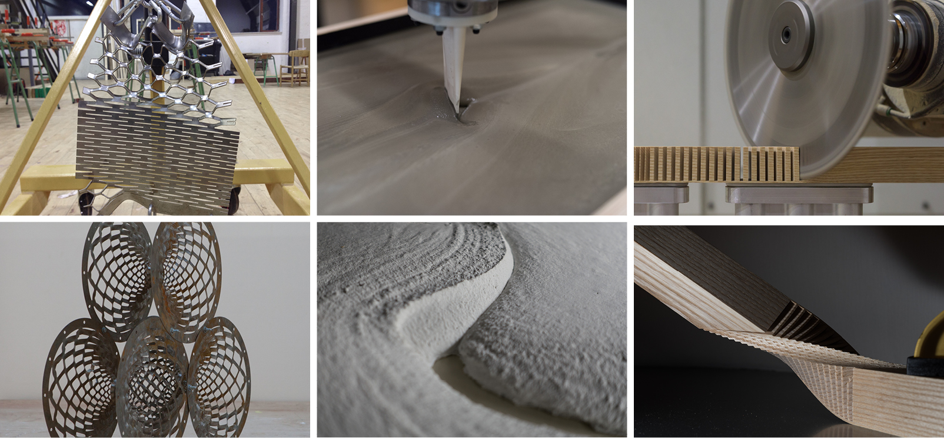

Implementation
The production within this ongoing experiment is outlined by the experimental framework of the Ph.D. project. The materials wood, steel and concrete together with the processes of subtraction, division, addition and transforming, defines the starting point for every test. The tests can incorporate as many or as few of both materials and processes and needed and be supported by other relevant materials and processing strategies. The encounter of material and machining will play a significant role in all arrangements, but the juxtaposition of materials, as well as the combination of machining types, can be just as relevant.
An unremitting shared focus for the investigations is an exploration of material properties and capacities. This includes the study of materials behaviour and response, as well as tolerances in relation to specific types of processing. The materials and processing are always looked upon as actual existences and causalities, meaning that they are involved on their own terms - not as representations of other scales, materials or notions. The role of the material and the processing changes depending on the setting for each investigation, but are in every case sought to be explicit articulated.
For every experiment, or sub experiment, an amount of information is needed to perform the processing. The information needed for machining can either be coded directly in the language native to the machine or derived from a digital drawing. In the latter case, the digital drawing can have many forms and its underlying data come from many types of geometry or descriptions. Throughout the project, the machines have been instructed by both coding and drawing. The drawing has by far been the most unfolded starting point for the instructions. Sometimes the drawing has been direct instructions for tools to follow; other times toolpaths have been extracted from geometry or surfaces. Both situations have been either generated by drawing ‘by mouse clicking’ or by parametric inputs depending on the specific intention or applicability. Combined, these possibilities of instructions and drawings give a quite wide turf for exploring. Not every choice made in this regard have been thought through, but the consequences have been gathering and scrutinised in order create a qualified pool of knowledge for further development or more focused experiments.

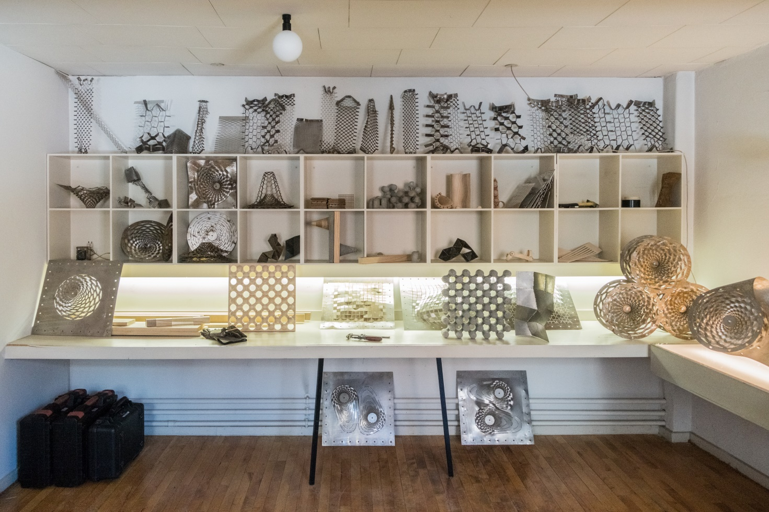

The accumulated mass of experimentations is in particular manifested through the collective physical outcome. The material objects serve as entities on their own, open for rendition, refinement or development. However, they also operate as coordinators and summaries for the processes and findings correlated to their emergence. Through every object and their marks, traces and memories the underlying actions can be revealed.
In the encounter of machining process and materials new form is produced. It is, however, not always the final form that occurs after machining. This result from machining is in many cases an intermediate result that sets important framework for further work. This can be in a situation where the machining is happening in a supporting material – e.g. in the production of formwork, where concrete eventually will take advantage of a machined framing. In another situation the machining might not be an aspiration for a predetermined form or it might simply be a preparation for further processing. In these settings, the machining can be described as embedding information into the materials through their processing. The information, in the form of physical change to the material piece, can be the starting point for a further transformation.
As with the drawing, the materials’ different roles in the process create a spectrum for exploring. The material can be almost passive and receive the form from the acting machine or formwork. Or, it can adopt a more active role and bring forward potential further transformation through or after the processing. These different scenarios have played a considerable role throughout the arrangement of and reflection on the experiments. For all experiments, the altering or transformation of materials have played a major role, but for some additional transforming processes after the machining has become the essential part.
With many variables ranges from initial drawing, material choice, machining parameters, the role of materials, transformation possibilities, etc. the combined workflow consists of many options that need a choice. These choices can be planned or sketched out ahead, but do to the uncertain nature of most experimentations, the choices will in most cases need to be adjusted, reconsidered or made during the execution. This circumstance becomes the centre of rotation for the material amassing. Compared to a situation where a drawing is exact information of how the final result is going to be, these experiments are based on an investigative nature where the result is a consequence of interaction with drawing, materials, processing and post processing. The domain of decision making is stretched out over several elements of a process meaning that to make a change or a new iteration the point of engagement does not need to be situated in the beginning, but can just as well be an intervention in the middle or end of the process. This possibility of changing and modifying is well-known to architects. This is an essential part of sketching and developing of design. When this is done digitally, the responsiveness of immediateness is even closer. The strength of digital drawing – repetition, copying, moving, mirroring, etc. – creates a true design environment of virtualities. By including this thinking in materials and the machining of those this virtual space seems to extend beyond the digital interface of computation and into the real space of materials. This widening of virtual design space is explored and demonstrated through the collective pool of production with this accumulated mass of material transformation.

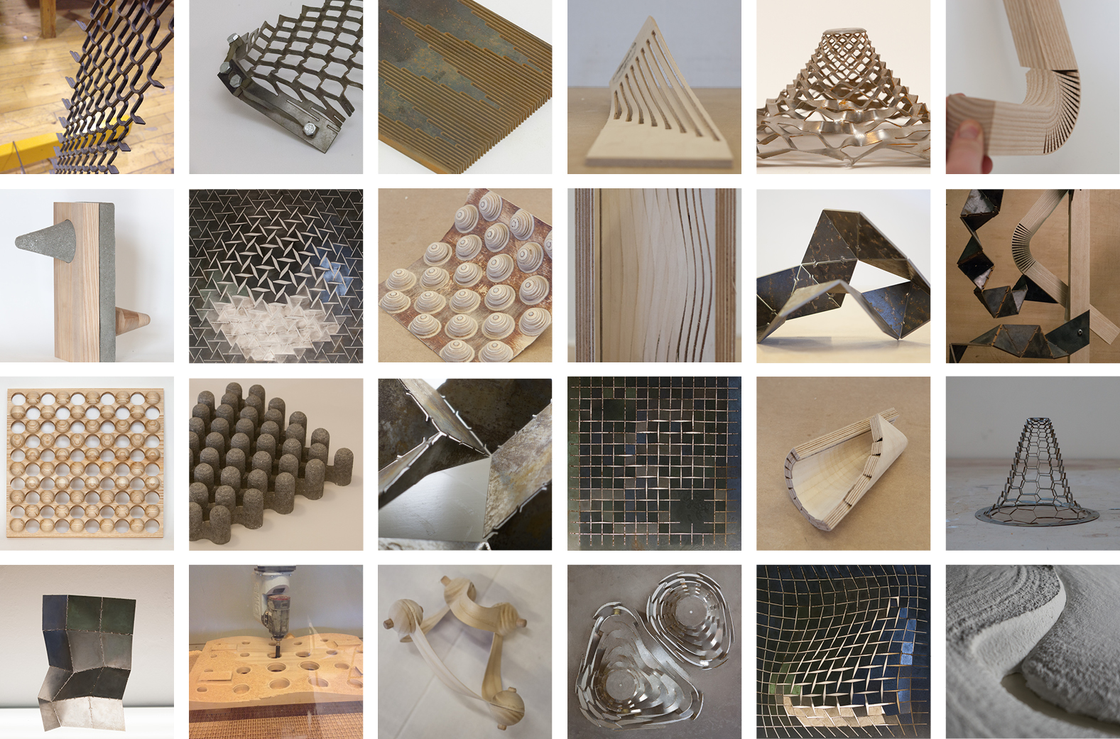

The forming of this ongoing accumulation is serving as an initiator for other more focused experimentation or as inspirations or eye-opener for relevant areas that need exploration. The running expanding of this accumulation concurrent with other more focused experimentation ensures a pipeline of potential new investigations that can be explored next, but also functions as an apparatus for assisting and qualifying the discussion crosswise activities. Photos and examples from this unfinished collection of materials show creations that are stepping stones for other experiments, but also creations that are reflections of shortages or absences of other experiments. These accumulated transformations are anchored in this the project Bespoke Fragment, but has a starting point before and a life after.

EXP 2: Intermediate Fragment

Intention
The intention of this project in twofold. First, the intention builds directly on the notion of the drawing as a tool for embedding information into the material through fabrication. The materials properties are seen as the basis for the creation of new capacities in the material. The new capacities of the material are realised through the machining but exist solely as a virtual possibility until actualised in physical space. The expanding of the virtual domain from digital space to physical space is intended to be tested out in this project. In continuation of this, the shuttling between digital and physical through virtualities is seen as a strategy to create a coherent, productive cycle of material investigations directly connect to the process of drawing.
Second, this experiment is aiming for a greater level of completeness than found in some of the other experiment. The idea is to create a production that can wrench the reading of being a material test and lab experiment of itself and instead be seen as a fragment of architecture. The intention is believed to be achieved through a focusing and refinement of finding and through scaling. Even though all materials, no matter sample size or dimension is seen as being real and 1:1, a certain size is needed to understand an object as a spatial fragment of architecture.

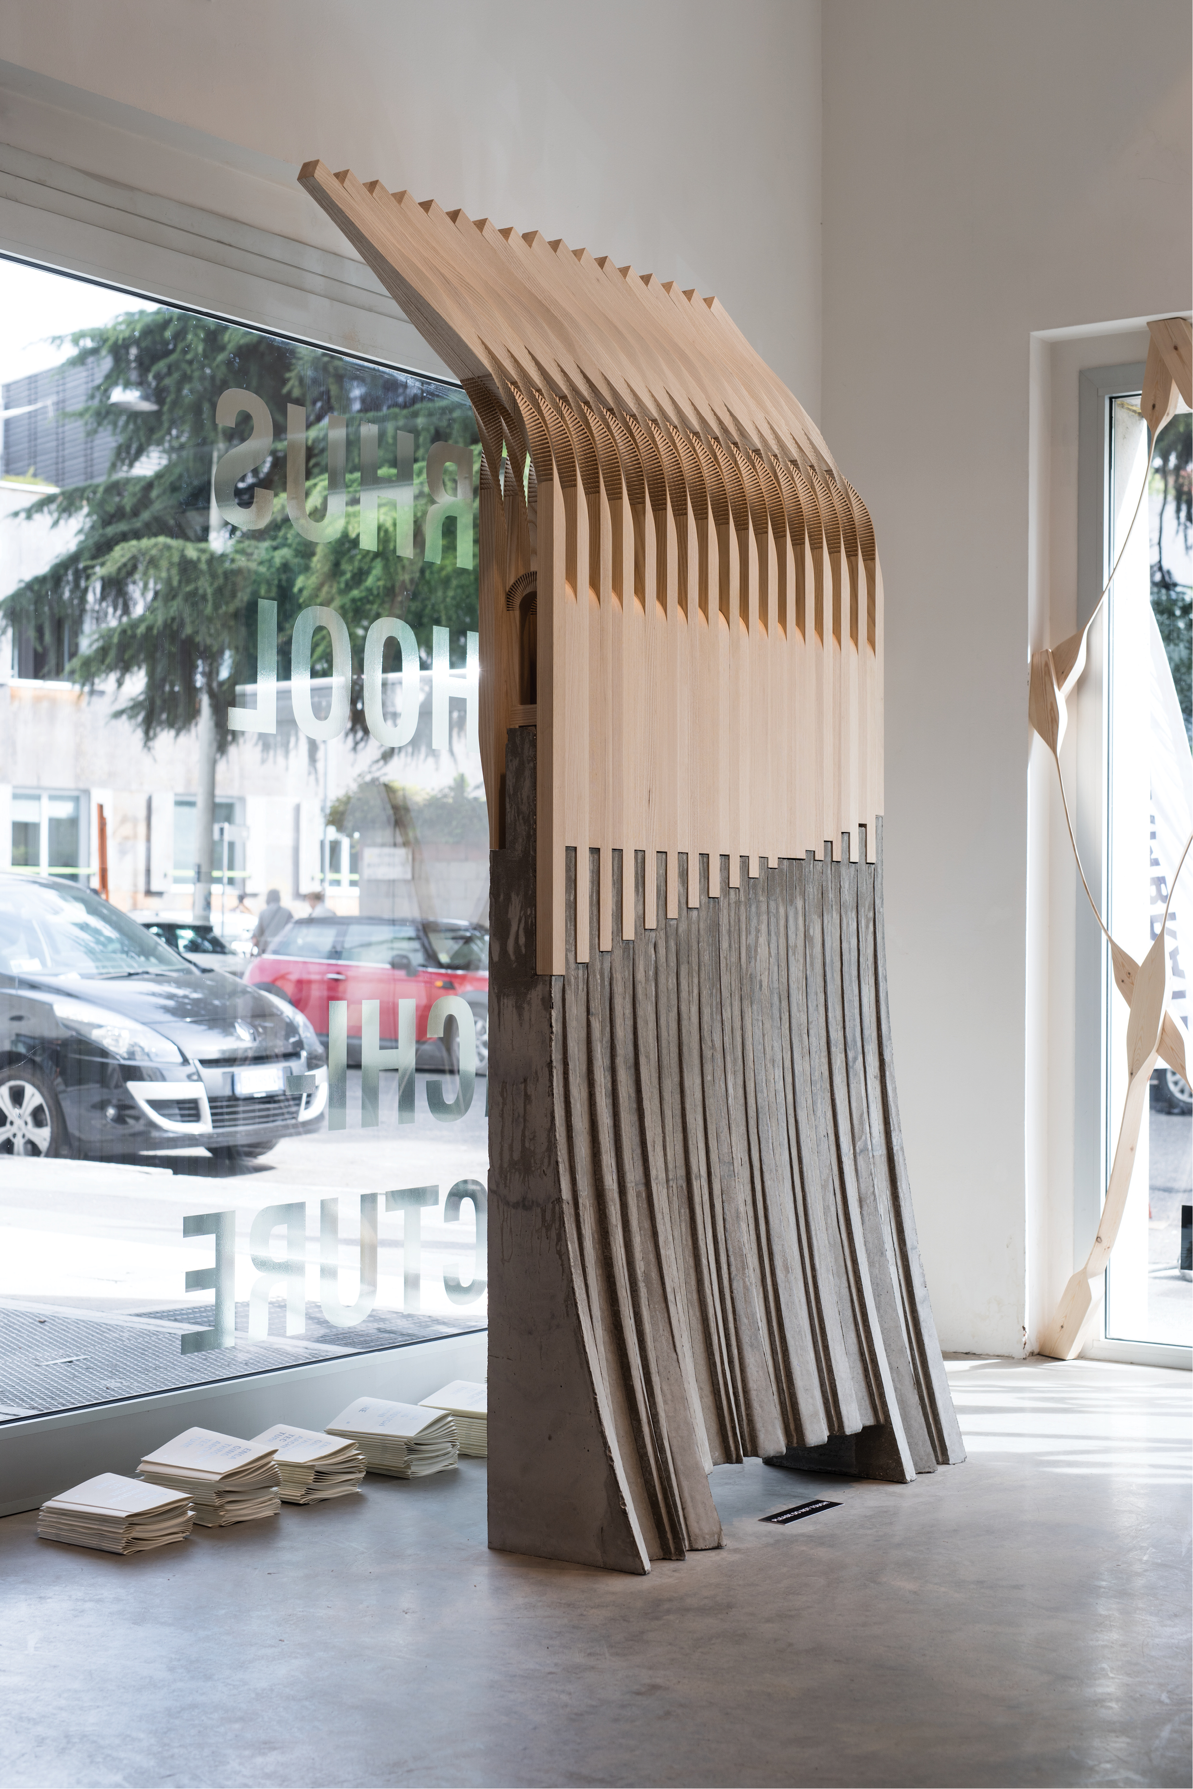

Implementation
The starting point for this experiment is a group of material test found in the pool of Accumulated Transformations. In a series of smaller experiments different types of wood was combined with various types of subtracting machining. In many cases, the resulting wooden part was attempted transformed. The transformation could either be a simple manual-mechanic procedure or involve steaming or soaking to provoke a reaction from the material capacities.
The machining itself was tested out with a number of different relations between drawing and specific machining. A focusing was made on a specific type of drawing and specific tool. Drawing was developed in its simplest form with no representational intend. The lines of the drawing in digital space were directly translated into paths for the tool. The tool chosen was a 330 mm circular saw attached on a 5-axis CNC machining system. The simplistic notion and style of drawing combined with a direct translation to G-code made a short and uncomplicated workflow from mouse clicking to saw blade. This setup almost gave direct access to tool control and through that a very flexible, but accurate way of controlling this subtractive machine. While the orientation and direction of the saw blade, luckily, was in full control, the machining in wood was, to begin with, a highly uncertain process. Different cuttings of the wood grains result in different reactions. Internal tensions are released; new distributions of forces are made. Combinations of more, or numerous, cuts quickly create results whose logic is not easily readable. Naturally this process led to a lot of testing and trying – keep in mind that this initial exploring phase had no other purpose than the establishing of an overview of possibilities and a searching for revelations
The experiment became focused on complex variations of traditional kerf bending techniques, where a piece wood is cut in order to bend it in a direction normal to the kerf. Understandable this techniques is dependent on the remaining wood and the strength and orientation of the fibres in the actively bend length.

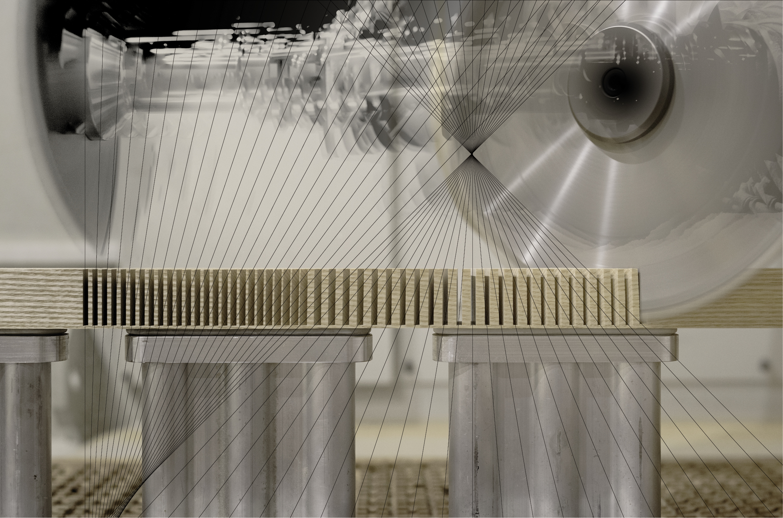

The drawing for these kerf bending investigations started out as explorative arrangements of lines that, in their earliest stages, had no or very little experiential foundation. Instead, they served as probing instruments in the process of finding relations and defining parameters in the encounter of materials and machining. Through the repeating experiments the drawings, however, gradually build up experiential knowledge around the investigated procedures. Every iteration gave a material feedback to the drawing loop.

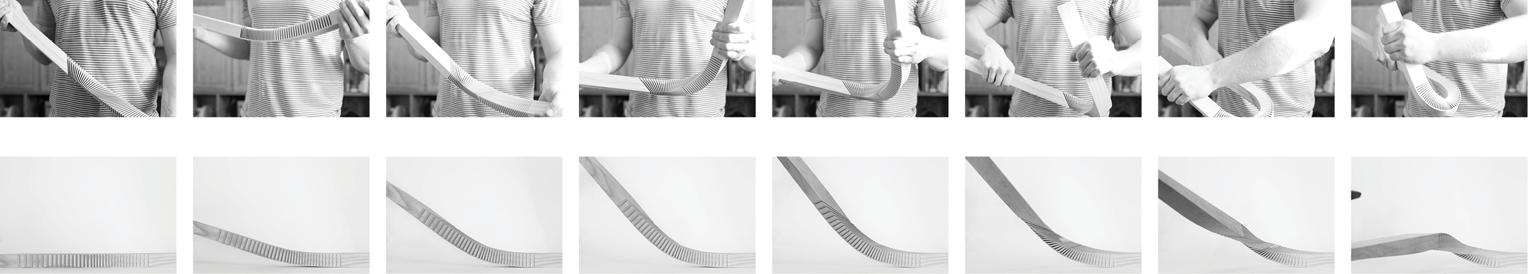

While defining a field of possibilities, iteration by iteration, the experiential gaining increased, taking the drawings from mainly being uncertain catalysts of surprise, to being vessels for obtained know-how. Increasingly systematic approaches to the fabrication were utilised, creating an overview of decisive parameters, the definition of those and their impact on the results. Kerf depths, cutting angles, kerf distribution and spacing, overall machining length, as well as the wood type and orientation, all have a definite impact on the bended shape that the machined piece eventually will be able to transform into. This knowledge, listed as parameters, in interplay with the machined result, was considered a combined design space and structural logic from which form and spatial compositions could be retrieved. This material and machining experience created foundation for creating several versions of kerf patterns that could facilitate the bending of wood into surprisingly agile shapes. These physical shapes were reclaimed into the digital domain using 3D scanning and contact probe metrology. This allowed for a geometrical analysis of the resulting shape in relations to its preceding machining, as well as a basis for digital compositions and drawings with the shapes combined. Eventually, ash wood was chosen as the prime material because of its long, flexible and strong fibre structure.

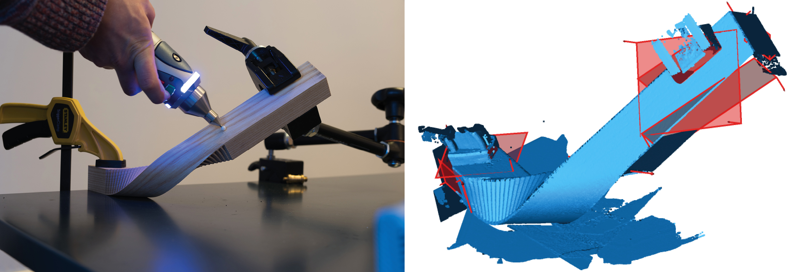

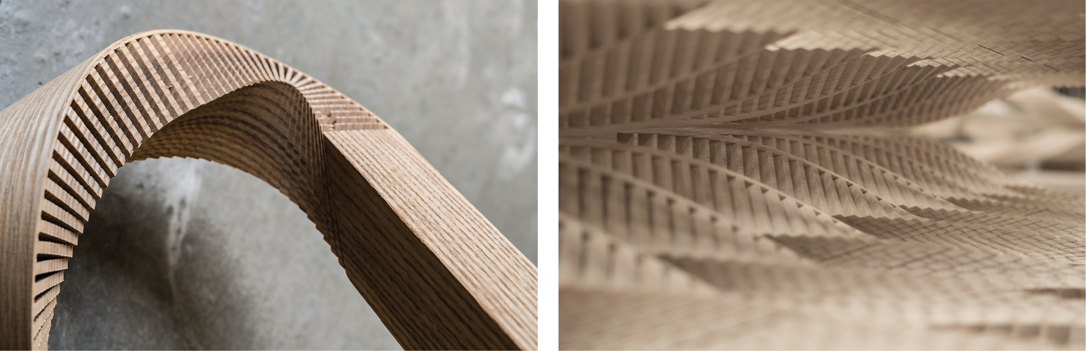

During the process of wooden investigations, similar, although less extensive, experiments with concrete and CNC milled formwork was carried out. This process gained speed by a time where the wooden experiments already were well developed; resulting in more focused and biased experiment and design strategy. The concrete investigations eventually acquired an interplaying strategy for the design developed through the wooden experiments. Opposite to the drawings for the wood, the formwork drawings were drawn as explicit solid geometries based on shapes passed on from the result of the wooden transformation. The bended shapes and curved contours from the wood were passed on to the design of the concrete. Formwork was routed in expanded polystyrene (EPS). EPS is easy to machine, but the result is miserable for casting due to its open texture. Therefore, surface treatment is needed. The EPS negative solids where looked upon as blank three-dimensional canvases for imposing surface features that could brace the design – and in that way extend the active process of designing into the material. Different materials, including acrylics, treated wood, textiles, oils, solutions and more, were tested out. A partial lining with sheet latex cut by a digital cutter in combination with areas treated with an acid-based, retarding solution was chosen. This arrangement offered smooth surface texture where the latex was applied and a rough erosion of the surface where the solution was active. Playing on the capacities of the concrete, the formwork created an inside-out effect to the casting that followed and continued the ribbon-like effect achieved by the machined and transformed ash wood.
The result of the extensive testing and prototyping turned into a build bespoke, architectural fragment. The fragment exists as a component of coherent transition between ash wood construction and concrete base. The structure is an intermediate result based on the quantity of experimental results and the experiential knowledge gained from the research process of combining digital drawing and fabrication tools and an investigation in material capacities. While temporary acting as an exhibition piece, Intermediate Fragment is not to be considered a final result. It is to be considered an architectural fragment belonging to a process containing a quantity of informative, actual and representational elements. At the same time, the process also starts to shape a production method and strategy around the design to be. Potentially this type of material and machining driven design (van Bezooyen, 2014) will be not only able to suggest new spatial use and shaping of materials in architecture, but also be able to suggest the process of manufacturing these in a later construction phase.

Open-ended discussion and concluding remarks
The bridging of drawing and realisation is one of the nerves of this project. This interest is in direct prolongation of the current state of architectural drawing and representation.
Architectural production is traditionally characterised by existing of a number of different representational pieces altogether bringing forth a collective explanation and understanding of a coherent idea (Leatherbarrow, 2001). Compared to art, architecture is not developed within the same materials and mediums as the results, the buildings, to be (Evans, 1997). Architectural representation is often multifaceted, engaging the project through different mediums and from different perspectives. Scale models, sections drawings, artistic visualisations, detail drawings, conceptual diagrams, material samples – they altogether try to form a notion of what the specific architecture and an architectural idea are about. Individually every piece of representation in this set can be of artistic, professional or technical value but newer alone do they deliver the cohesive understanding behind an architectural project (Leatherbarrow, 2001). The architectural set is representational and altogether forms a domain of individual, but relational fragments. Put together; these elements create the context for understanding a proposed architecture, but also an understanding of the architect’s underlying work. In that way, architectural representation often compresses both a conducted work process and the idea of a future construction into a complete set.
As noted, the use of digital fabrication tools has proven to bridge between digital drawing and material, making the architect able to inform production through drawing. Mainly in academia, but also in office practice, the linkage has resulted in a current era of pavilions and small-scale experimental architecture types. They seem to discuss this coupling while testing out new material and construction system found through these processes (Gramazio et al., 2014). While many of these structures stand on their own and, to a certain degree, can be regarded as autonomous pieces of architecture, they are not buildings and their existence do not replace the need for buildings - and were not intended do to so. Instead, they propose new spatial possibilities, through new ways of designing structures and machining material, that potentially could be implemented in future buildings.
On the basis of this existing field established around digital fabrication in architecture and the experiments carried out in this research project, I suggest that we see this new type of architectural production as an expansion of the already existing set of representation. Tangible, material constructions provides another perspective on both the creation and presentation of an architectural idea and should in that context be seen alongside with drawings, models, diagrams, etc. The on-going creation of architectural representation will always play a vital role in the designing of architectural space and generation of spatial ideas. Sketching and modelling in any medium will provide a constant, experiential feedback to the design process. Specific for the material representation created through digital fabrication is, however, its ability to be both introduced very early in the process and throughout the designing continuously evolve alongside with the development of the associated drawing and the machining method. It is the claim that this type of representation can drive design, but also evolve into information that is not only picturing but holds information for realisation itself.

While it is clear that this paper does not provide a full overview in the PhD-project, which it is situated in, it is the hope that the outlined themes and discussion together with the two short glimpses of experimental work provides insight. The project is mainly built around physical experimentation in laboratory facilities. This is, of course, permeating the type of production and knowledge created within the project. The experiments, as well a the act of experimenting, within the field of architectural research, is both, simultaneously, generating types of discussions and contexts for this production and knowledge. It is the hope that components of the work can be of relevance both in the context of academia and in architectural practice, and that some ideas and notions from this project, in the future, can be implemented as working strategies in both.

References
Aagaard, A.K., 2015. Materials Driven Architectural Design and Representation, in: Tangible Means - Experiential Knowledge through Materials. Presented at the EKSIG 2015 - International Conference 2015 of the Design Research Society Special Interest Group on Experiential Knowledge, Design School Kolding, Denmark.
Ayres, P., 2012. Persistent Modelling: Extending the Role of Architectural Representation. Routledge, Abingdon, Oxon England ; New York, NY.
Callicott, N., 2001. Computer-aided manufacture in architecture : the pursuit of novelty / [WWW Document].
Delanda, M., 2007. Opportunities and Risks. Domus No 901, 192–193.
Deleuze, G., 1991. Bergsonism. Zone Books, New York.
Deleuze, G., Parnet, C., Deleuze, G., 2002. Dialogues II / [with] “The actual and the virtual” ; translated by Eliot Ross Albert. Continuum, London.
Evans, R., 1997. Translations from drawing to building and other essays. Architectural Association, London.
Gramazio, F., Kohler, M., Willmann, J., Eidgenössische Technische Hochschule Zürich, Chair of Architecture and Digital Fabrication, 2014. The robotic touch: how robots change architecture.
Huerta, S., 2006. Structural Design in the Work of Gaudí. Archit. Sci. Rev. 49, 324–339.
Kolarevic, B., 2008. Chapter 10: The (Risky) Craft of Digital Making, in: Manufacturing Material Effects: Rethinking Design and Making in Architecture. Routledge, New York.
Kotnik, toni, 2011. Experiment as Design Method. Integrating the Methodology of the Natural Sciences in Architecture, in: Moravánszky, Á., Kirchengast, A. (Eds.), Experiments: Architecture Between Sciences and the Arts. Jovis, Berlin, pp. 24–53.
Leatherbarrow, D., 2001. Architecture Is Its Own Discipline, in: Piotrowski, A., Robinson, J.W. (Eds.), The Discipline of Architecture. University of Minnesota Press, Minneapolis.
McCullough, M., 1996. Abstracting craft: the practiced digital hand. MIT Press, Cambridge, Mass.
Sheil, B., 2005. Transgression from drawing to making. Archit. Res. Q. 9, 20–32.
Songel, J.M., Otto, F., 2010. A conversation with Frei Otto. Princeton Architectural Press, New York.

