International Conference - Unspoken Issues in Architectural Education

The Operational Drawing – a future workshop for undergraduates at the School of Architecture. CPH
Research-based teaching

J a c o b S e b a s t i a n B a n g
Architect, artist, assistant professor
Institute 4 – Design and Communication – School of Architecture – Royal Danish Academy
Philip de Langes Allé 10 – 1435 Copenhagen K – Denmark
Tel: +45 26 70 63 66
Email: Jacob.bang@kadk.dk

A b s t r a c t
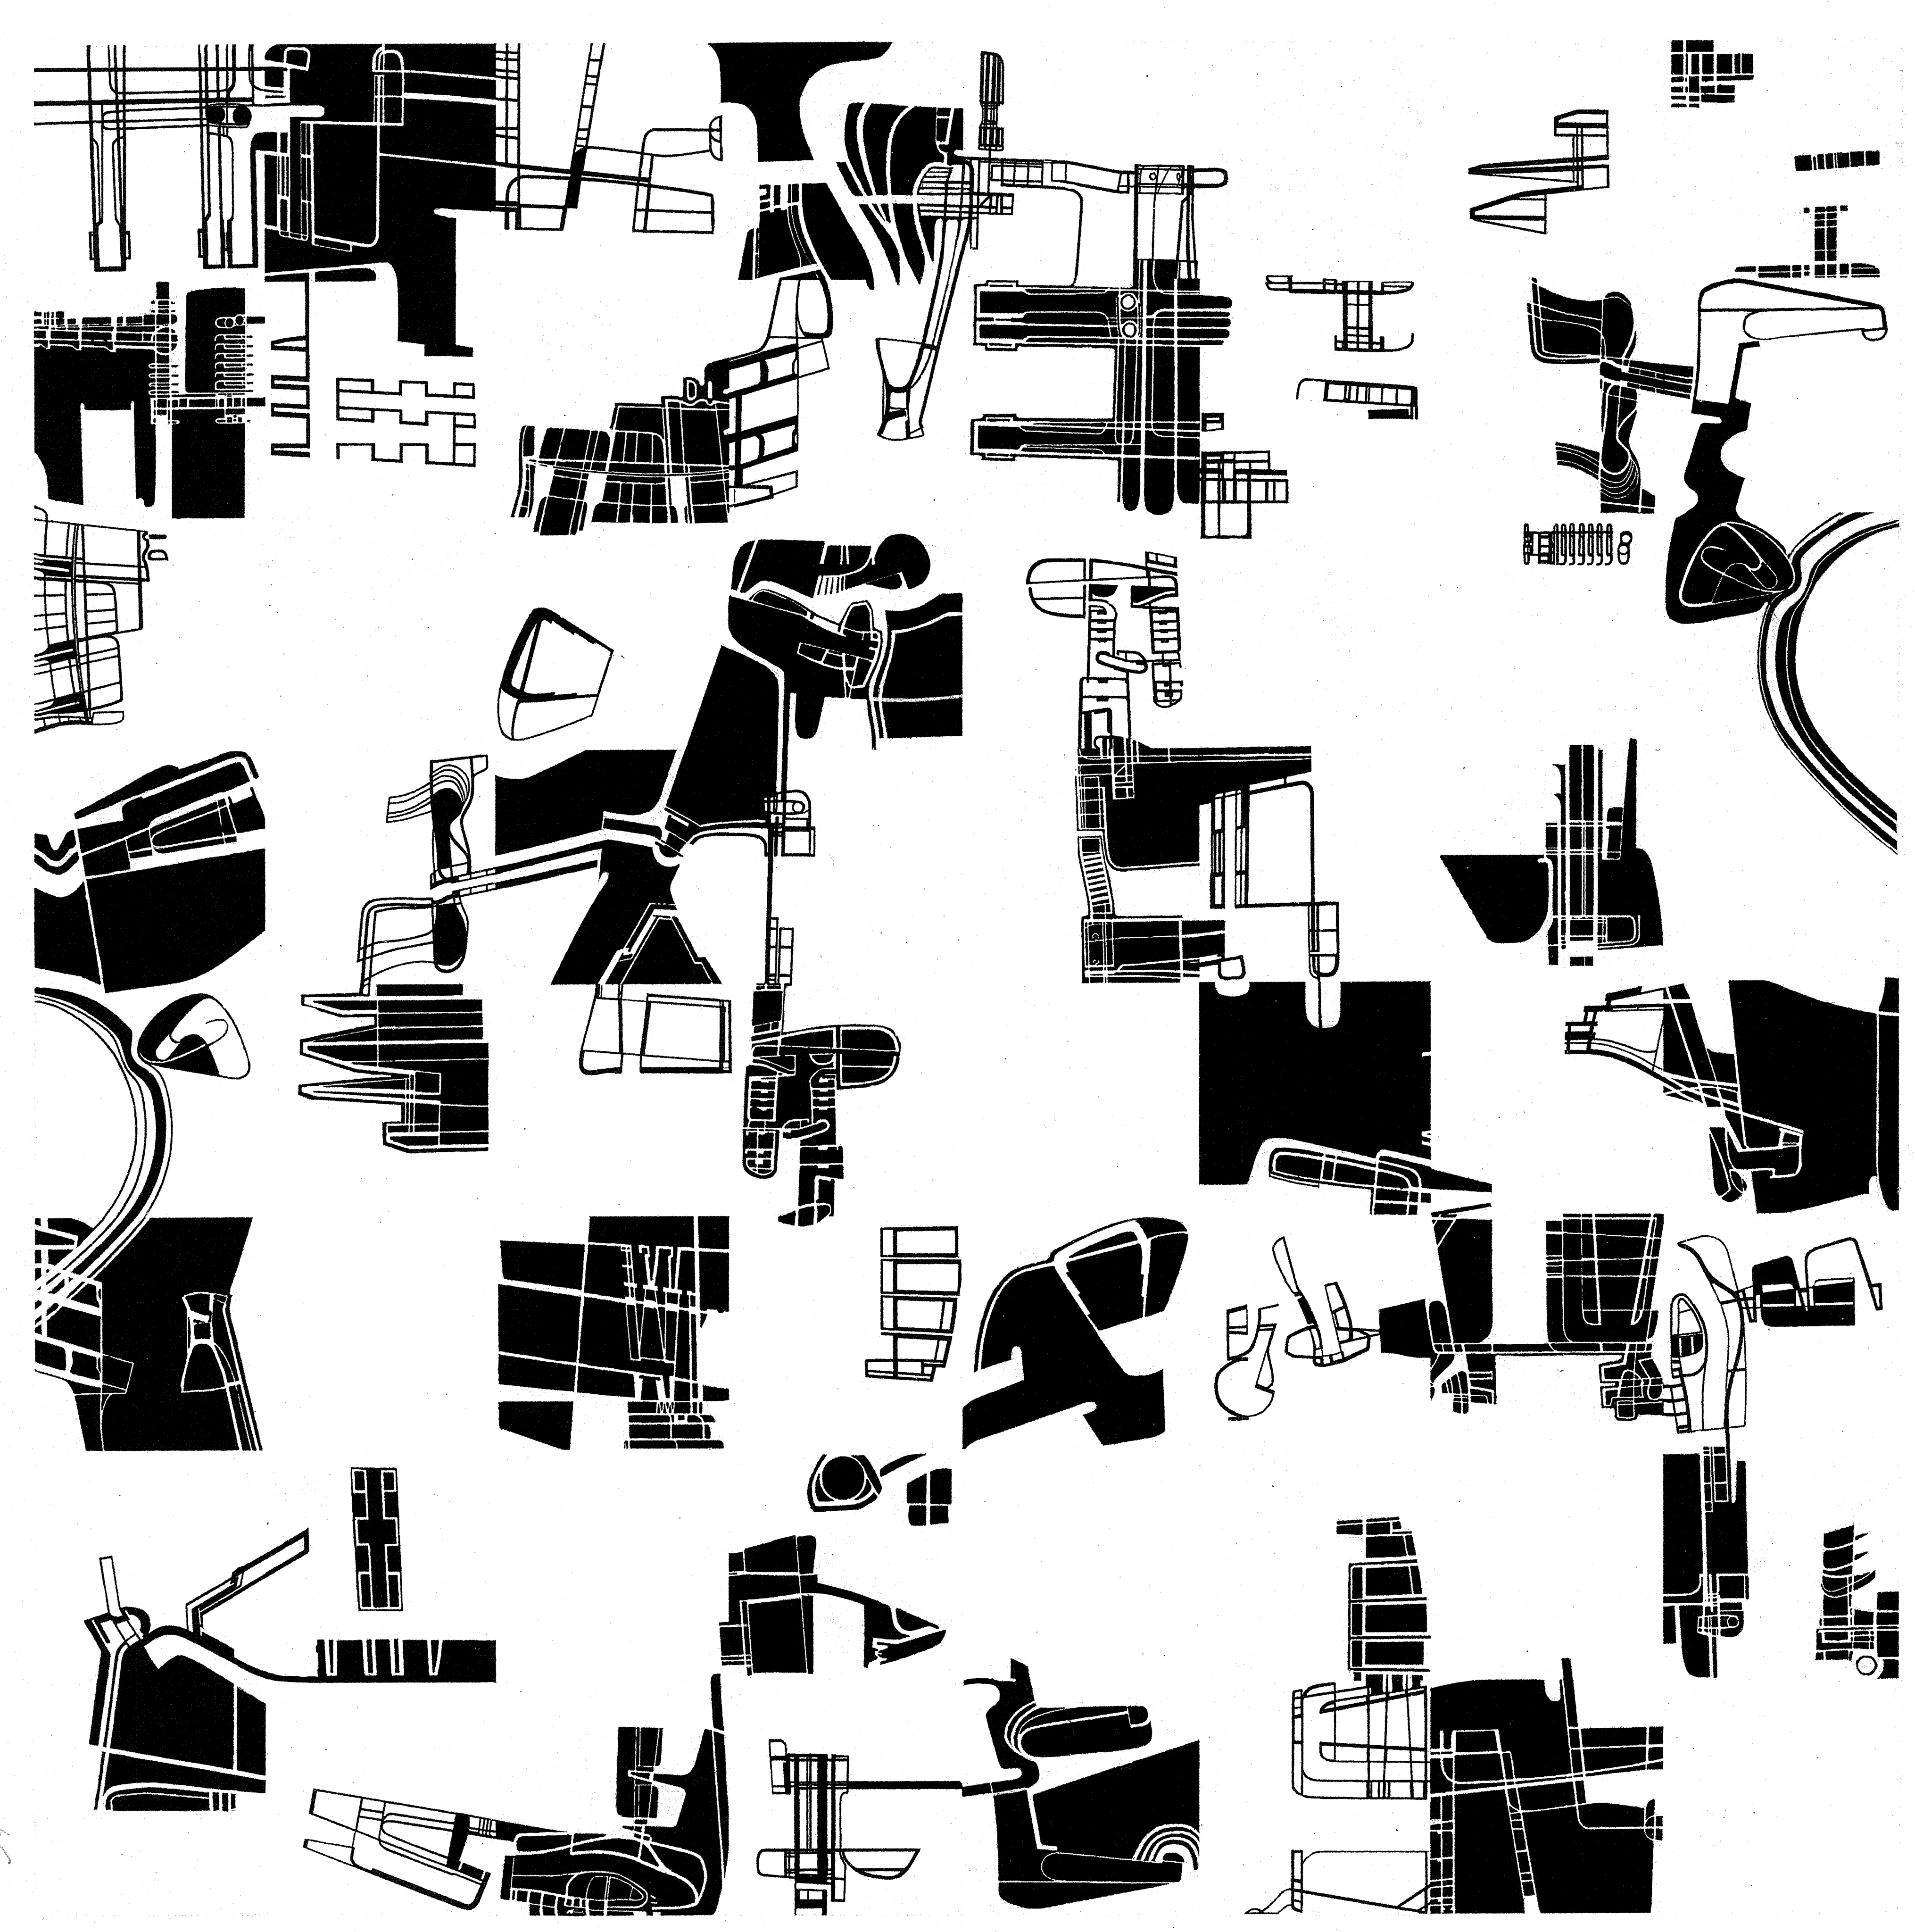

Fig. 1. Drawing. Field. Ink on paper. Jacob Sebastian Bang
The gathering of different drawn fragments into a whole.
A B S T R A C T

The Operational Drawing – a future workshop for undergraduates at the School of Architecture. CPH
Research-based teaching

This abstract unfolds how I use the drawing in a phased process where the student works in a series of drawings to develop architecture. The workshop is aimed at undergraduates. I think that working in a series provides a dynamic and extensive production with a broad investigative and analytical process that expands the field of interest and awareness about procedures. This is a way to reflect on your work and also a way to produce workshops for students.

The drawings emerge in the decoding of a series of models (fig.2.) in order to start creative processes and transformations where students can develop their project and analytic skills. In the decoding or reading of the model they try to establish the models special character, its operational possibilities and also to invent a way to express them through drawings.

In this text I will show examples of my own work. These explorations will be part of the program in a workshop that takes place in the beginning of December 2013 followed by my reflection in words accompanied by examples of the students works: a paper / submission for the conference Unspoken Issues.

To get the students started quickly I provide them with my own studio models (fig.2.). The point is that these models are not anything yet. They are models that come before the idea - something that can be developed into an idea.

The students can transfer experience in the study of my models to their own work and make a personal material in a subsequent "defiguration" or further development of the material. It requires a lot of work from the student’s side with dedication and concentration.

I find it interesting to bring the student into an area he/she has not been in before. A space that breaks with a perhaps more conventional way of perceiving and creating architecture. Not just to create an architecture that is different, but to develop the student’s way of questioning their work: via various types of drawings that should pique the curiosity and support and initiate a creative sketching process in which the students are both intuitive and analytic when they are testing the model’s resistance and creates an experience they can take with them in their future work.

The analysis detects different observations - where the students open up the project and creates opportunities for themselves in the establishment of a series of drawings - a collection that can be examined, a collection of artistic work that must be reflected upon.

To hint at the possible outcome of working in a series of drawings and representation techniques, I have described a number of series/depictions of my own work below. There are numerous drawings and stages, but I have chosen to show a minor selection to stick to the abstracts limited format. All drawings are representations of the models.

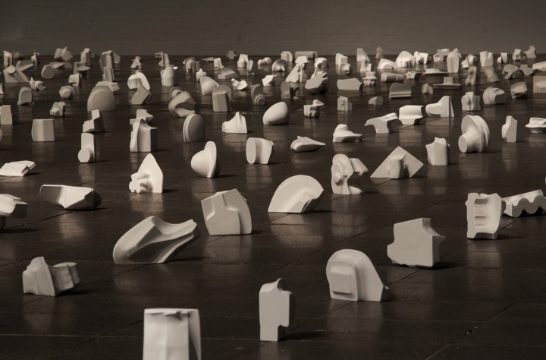

Fig. 2. From the exhibition ”1001 Models.” September 2012. CPH. Plaster models. Jacob Sebastian Bang. Photo: Michael Dam

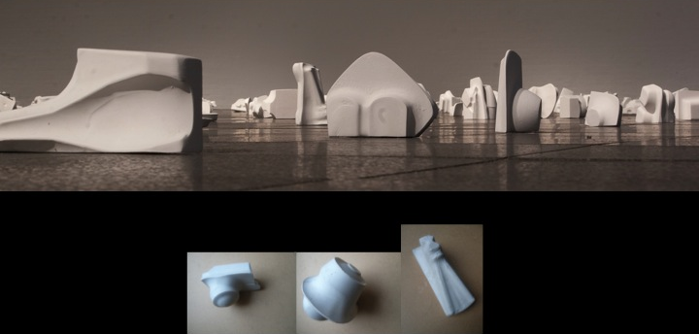

Fig. 3. From the exhibition ”1001 Models.” September 2012. CPH. Plaster models. Jacob Sebastian Bang. Photo: Michael Dam

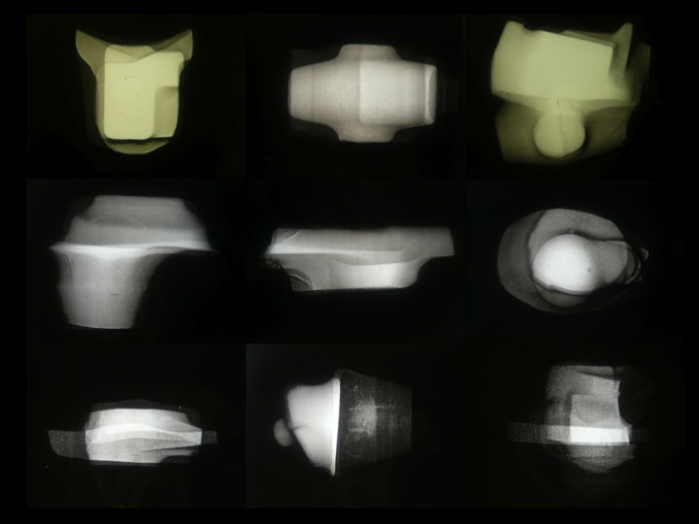

Fig. 4. X-ray drawings. 9 differnt models. Xerox on film. Jacob Sebastian Bang
The models photographed from all sides on film and summed to a total picture

Fig. 5. X-ray drawings. Xerox on film with black contours. Jacob Sebastian Bang
On the X-ray image is drawn a sharp contour, which defines the volume.

Fig. 6. Decoded X-ray. Jacob Sebastian Bang
Different depictions of the models in drawing. A kind of plan drawings
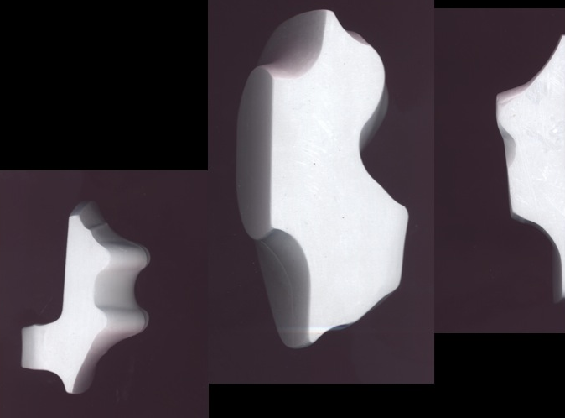

Fig. 7. Scanned models. Xerox

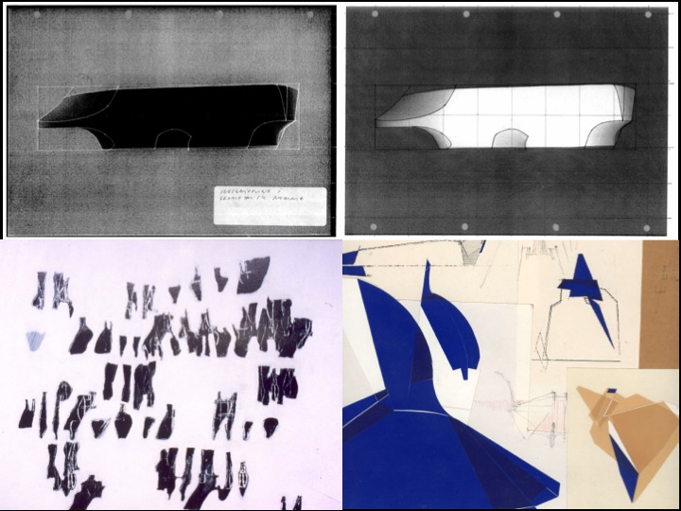

Fig. 8. Different representations: Xerox with painted ink (top), oilpainting (bottom left), painted paper on drawing (bottom right).
Jacob Sebastian Bang
Inscribed in a geometric frame. Different figures as sequences. Attempt to decipher different shapes or figures with colored paper.
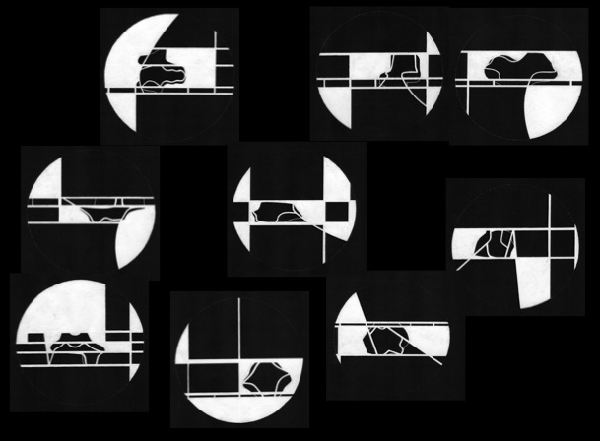

Fig. 9. Notations. Ink on paper. Jacob Sebastian Bang
Different figures inscribed in geometric frames.

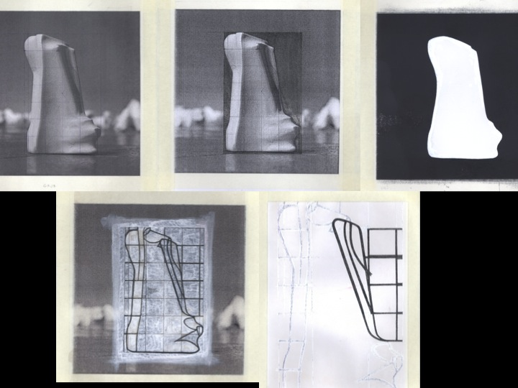

Fig. 10. Photo-drawings. Different kinds of decoding in drawing. Jacob Sebastian Bang
Different depictions based on the same photo of the model
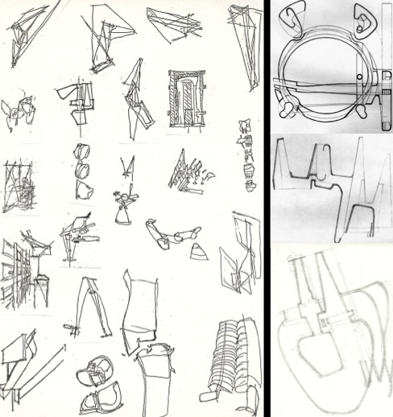

Fig. 11. Imaginative sketches. Jacob Sebastian Bang
Different experiments with an imaginative sketching in the pursuit of creating a collection.
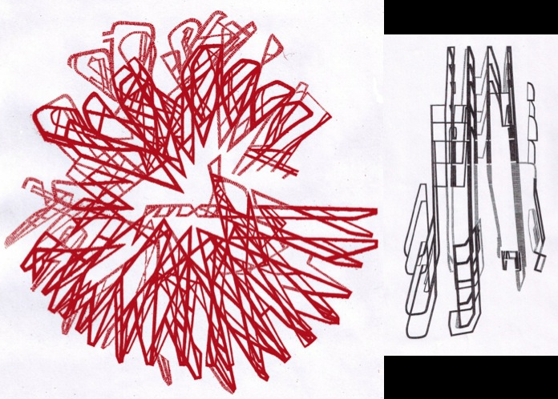

Fig. 12. "Repetitive sketches". Ink on paper. Jacob Sebastian Bang
The repetition of figures. A circular and a linear version. Elaborated further with ink.

