1. Praxis and Poetics: Research Through Design
2. Work In Progress

Abstract

Jacob Sebastian Bang

The Royal Danish Academy of Fine Arts, School of Architecture

Philip de Langes Allé 10

1435 K - Denmark

[Jacob.bang@kadk.dk](mailto:Jacob.bang@kadk.dk)

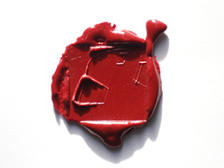

Figure 1. 20x20 mm. Sealing wax

I have created a collection of 1,001 models in plaster. To me it is interesting to make things that are not already in the world as the sculptor Carl Andre once said[1]. Things that no one asked me to create, things without a function but with inherent qualities as objects for further study and transformation into different series of depictions. I think that working in a series provides a dynamic and extensive production with a broad investigative and analytical process that expands the field of interest and awareness about procedures. This is a way to reflect on your work and also a way to produce workshops for students. It is in this artistic practice I experiment with architectural models and drawings in a quest for what I call ‘operational material’: models with inherent ideas, methods, rules and obstructions. The German painter Gerhard Richter put it in this way: “Meine Bilder sind klüger als ich”[2]. It is a process of analysing the material to identify potential creators of architectural processes and future possibilities by a comprehensive process of transforming models into new models and drawings both; ‘imaginative drawings’ and ‘analytically constructed drawings’. The plaster models are transitional models and have the potential as cognitive tools, but are also fragments in their own right. The operational model materializes in parallel with my fascination of watching something emerge; something which in the beginning is just itself - something that can be developed. It is a process of stepping back and forth. An earlier work could prove to fit into a new context: the work in its entirety, through time, is therefore a coherent work - an archive of research possibilities.

Author Keywords

Models; Objects; Collection; Representation; Creation

Research Imperatives

The artefacts that I have brought to the conference show different examples of models or objects from an ongoing creative process with a huge production that has spanned over three years. I have established an extensive collection of 1,001 different plaster models for exhibitions and further explorations in new models and drawings. These depictions are at the same time works of art in their own right as well as analytical material and possible concepts. The model is there before the emergence of an idea so to speak. In his book *Words and Buildings: A Vocabulary of Modern Architecture,* Adrian Forty shows this diagramas the “conventional” view on the process of architecture[3] (Forty, 2000, p. 32):

Idea→Drawing→Building→Experience→Language

My process is more like this:

Model / object→Drawing→Idea →Experience→Language

On the one hand you have the original work of art and the process of artistic creation and on the other hand the reflection of this work and subsequent development of rules and methods in a quest for what I would call ‘operational material’ or in other words different representations that could bring me closer to a translation of the plaster models into architectonic signs and potency – into *ideas*, manoeuvres and rules thus achieving an increased awareness of the model's inherent opportunities.

The research imperatives are:

To create a collection: objects to study; exhibition

The creative process: transformation of objects; representation

The reflection of the process: language

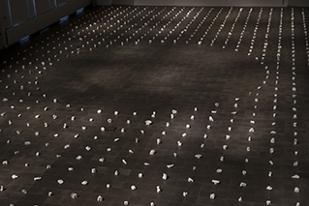  
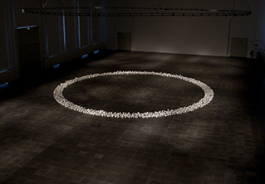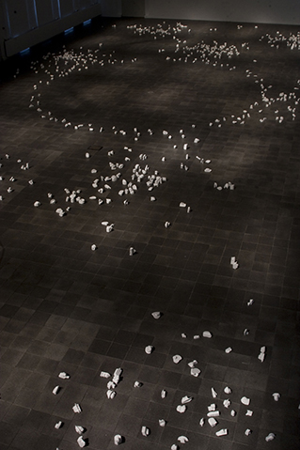

Figure 3. “1,001 Models”. Distribution: 2, 3 and 4. Photo: Michael Dam

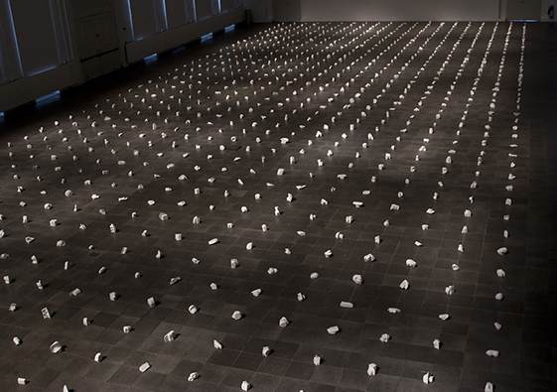

Figure 2. “1,001 Models.” Distribution: 1. Photo: Michael Dam

I am very interested in creating forms and shapes - objects without a function for further study. In this case 1,001 pieces! It is imperative to optimize the process when producing such a huge amount of models. The strategy is to develop a minor production to begin with to analyse how to plan or devise the future work in terms of: casting, moulding, wrapping, transportation, storage and so on – also in relation to later exhibitions (fig.2-3).

Research Process

***Production of moulds and plaster models***

I have produced hundreds of different moulds and combined them in several ways to cast 1,001 different plaster models (with common features).

***Evaluation of models and finishing***

I evaluated the models in terms of casting, logistics, proportions and what to cut off in order to obtain a cut surface for future registrations in drawings: I cut away pieces of plaster from the castings to ‘alienate’ them or simply to cut away features that irritates me. The cut is placed intuitive and done quickly. The amount of models and the repetitive aspect of the process make it easier and less painful to reduce the material.

***Exhibition of models***

I did a large scale exhibition at the Royal Danish Academy of Fine Arts - School of Architecture - a four-phased exhibition for a period of four weeks, to explore the 1,001 models, as a tool for different distributions or compositions that went on from very organized structures to a disorganized structure:

1. The grid
2. The negative circle inscribed in a grid
3. The circle
4. The dissolved version - laid out by my former students at the School of Architecture in Copenhagen[4].

***Evaluation of exhibition***

The four distributions were all floor standing as seen in some of Carl Andre´s works (see: Malpas, 1998). As Robert Morris put it: “The ground plane, not the wall, is the necessary support for the maximum awareness of the object” (Malpas, 1998. p.16).The models could be seen as a kind of space, negatives, as in the works of Rachel Whiteread (see: Mullins, 2004). As a generator in the four different distributions I used the ‘obstructions’ given by the exhibition space such as the size of the space, fire escapes, the tiling on the floor etc. The four different distributions made the exhibition very dynamic. It proved to be an interesting way of testing ‘urban structures’, density and how to conquer space.

  
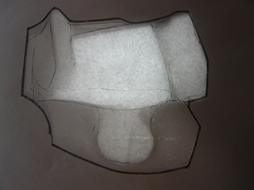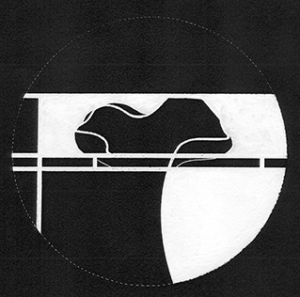

Figure 4. Representations 1-3. Scan, X-ray and ink on paper.

Figure 2. From the exhibition “1001 Models”. Distributions no. 2, 3 and 4. Photo: Michael Dam

***Representations and transformations into models and drawings***

Further explorations of the plaster models are done by transforming them into registrations of architectural potentials (fig.4). The registration of the models is a process of using both the classic analytic measuring of an object and more imaginative and inventive sketches to evoke the models specific nature, or inner idea, by studying simple photographs, x-ray images or scanned images of the model. Like in a cubist painting where the objects are dissolved into geometric shapes and fragments seen from every possible angle in one single glance. These depictions are addressed in various ways of drawing, into a series of more reduced stamps. The models are processed spatially, both as detailed architectonic elements, as models in high relief in various materials (fig.1 and 6), and, lastly, as structural models in strips of wood that make an evaluation of the spatial qualities possible (fig.7). I experiment with ‘mummification’ of plaster models with tape, covering models with jigsaw puzzle pieces, insertion of models into a framework and so forth.

***Evaluation of models and drawings***

The explorations in drawings are in fact obstructions or resistance in it self: different techniques and methods of registration. The thousand models are homogenous in expression, approximately the same size, have the same degree of detail and therefore comparable to a certain extent and may be subjected to the same process and set of rules. I try to reduce the material into stamp-like drawings with a keen interest in the stamp as an instrument or tool in itself as seen in some of my exhibited artefacts at this conference. It is interesting to define the stamp as a model with the properties intact as a tool for stamping. The models are both stamps and architectural models: an operational system with combinatorial possibilities (fig.6). I experiment with ‘repetitions’ (fig.5), movement, using the same stamp repeatedly and hereafter I elaborate with ink, inspired by for instance Duchamp’ *Nu Descendant un Escalier, no.2* from 1912. I work with the black and white balance in the drawing and the negative spaces between the figures (fig.4.3 and fig.8). I name places in the drawing: courtyards, walls, entrances, fences, stairs and so on.

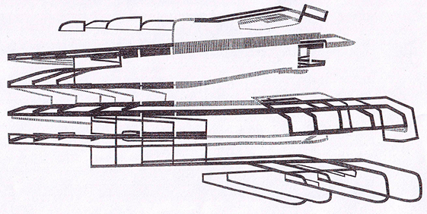

Figure 5. Repetition. Drawing. Ink on paper.

The different model experiments are pointing to the importance of changing scale and work with larger and more detailed models. I am currently in the process of interpreting a selection of a hundred plaster models in order to produce large models of approximately one meter in height. In that way I will change my view of the small floor models to something that relates more to the body and will eventually approach a more concrete architecture.



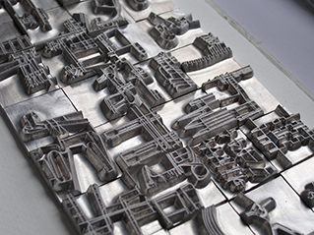

Figure 6. 20x20 mm. Stamps in magnesium.

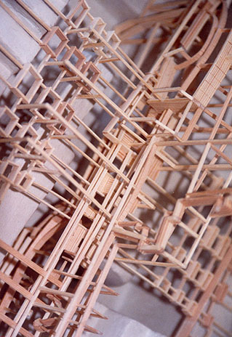

Figure 7 Spatial Structure. Wood.

Figure. 8. Blend. Field - drawing

Research Outcomes

The creative process, the models and the drawings are works of art in their own right and the main outcome of my research – art based research or research by design – what ever the correct designation is. To me it is a way of being an architect: to construct collections of models and drawings with architectural potency. I see new connections between works I've produced earlier and new works which are brought into relief and form part of the future work, as a particular view of things, a special way to choose to or from in the

material. I'm trying to find my references, the works of other sculptors and architects, to define the tradition I belong to. This is an ongoing process – a new and wonderful world. I see the different representations in models and drawings as documentation of the process but also as independent works in their own right - however they are supposed to radiate analysis and process. It is about constructing knowledge and meaning in a process-based practice. It is not a question of whether my work is art or architecture, because I believe that it lies somewhere in between, as it should do. It is already architecture when the first plaster model is removed from the mould and present it self as a new object in the world. I see the models as a kind of Architectural objects as we know them from Kazimir Malevichs famous models in wood and plaster *– the Architektons* (Drutt, 2003).

To me it is imperative to have a dynamic workflow with a broad investigative process that expands the fields of interests and desire to explore the various depictions. This in order to invent techniques and to create a personal expression and original works of art – and not least the reflection of this work and subsequent creation of workshops in relation to my teaching at the academy.

References

1. Drutt, M (2003) *Plates.* Kazimir Malevich: Suprematism. pp 204-209
2. Forty, A (2000) *Language and Drawing*. Words and Buildings: A Vocabulary of Modern Architecture. pp 32
3. Malpas, W (1998) *Carl Andre*. Land Art, Earthworks, Installations, Environments, Sculpture. pp 16, 52-59
4. Mullins, C (2004) *Untitled (one hundred spaces).* Rachel Whiteread. pp 71
5. Von Flemming, V. (1993)) Meine Bilder sind klüger als ich. Köln: DuMont. (DuMont Creativ Video).

1. “My art springs from my desire to have things in the world which would otherwise never be there”. I haven’t been able to locate the exact origin of the quote.
2. “My Paintings Are Smarter Than Me”
3. NB! Forty points out that: “…the process of architecture in a diagram whose wrongness will be immediately apparent but which will nonetheless provide us with an opportunity to discuss the relationship between the various activities that make up the whole practice of architecture”.
4. Aviaja Torbensdatter Hermann, Stefan Jesper Gründl, Martin Lukasiewicz, Theis Munk Sørensen, Jonas Johansen and Jonathan Houser