Guideline to easy-to-open packaging - a practical tool

Helle Antvorskov*, Birgitte Geert Jensen**
*Danish Technological Institute, Packaging and Logistics, Taastrup, Denmark, hean@dti.dk
** Aarhus School of Architecture, Design Studio, Aarhus C, Denmark, birgitte.geert.jensen@aarch.dk

Abstract
The consumers expect the packaging to be functional and to fulfil their specific needs in every way. A Danish survey showed that at least 40 per cent experience difficulties, when handling and opening packaging at least once a month, and as a consequence, 16 per cent of the consumers refuse to buy the product next time they go shopping [1]. The issues are worsening due to the expansion of the elderly population in the upcoming decades all over the world. In Denmark the amount of people in the age more than 65 years old will rise to index 170 in 2050 compared to 2010 [2]. It is also noticeable that 680,000 people in Denmark have difficulties and feel pain using their hands, which account for 17 per cent of the adult population [3]. Therefore, the chance of excluding a part of an enterprise´s target group is very likely, making easy-to-open packaging more relevant than ever.

The project “User-driven Guideline for the Industry: Accessible Packaging for Elderly and Disabled” seeks to address these issues. The main deliverable is a web-based guideline. The guideline contain collected knowledge regarding the attitudes of the consumers and issues to address about packaging design, also, the guideline contain a step by step process to develop easy-to-open packaging. The guideline is constructed in a way that allows the enterprise to pick and choose in respect to the enterprise´s needs and competences. The main focus in the development of the guidelines has been to produce a tool that function in a practical manner instead of communicating the absolute scientific truth.

The guideline has been proven in cases with five enterprises within the food sector. The presentation will contain an illustration of different elements of the guideline, for instance a practical tool calculating the amount in per cent of males and females able to open different designs of packaging. Also, the testing of the guideline in actual enterprises has provided experience with “to do´s” and “not to do´s” in the development process.

Keywords
Easy-to-use packaging, User driven innovation, Guideline

1.0 The importance of easy-to-open packaging
Many manufacturing enterprises are poised between the interests of consumers and business requirements when it comes to designing packaging. On the one hand, it should be easy to open packages, boxes and cartons, for there is no advantage in irritating customers by making it difficult to get to the product. On the other hand, it can be expensive to design new types of packaging. Development is costly and the solution may require the consumption of more materials for new packaging. This affects the price, which in turn may damage the enterprise’s competitiveness. However, many aspects speak for easy-to-open packaging.
1.1 Registration of accidents
One of the consequences of unmanageable packaging is that consumers are cutting themselves. Table 1 below provides a breakdown of the incidences of packaging-related accidents by life cycle stage of the packaging within in the household [4]. 75 per cent of all after-use accidents occur between the ages of 1 and 24, with men being 30 per cent more accident-prone than women. Two main packaging types are dominant in the incidences of after-use accidents. These are glass bottles and food cans.
The number of domestic accidents with food packaging and tools account for 2,500 accidents in Denmark (European Home and Leisure Accident Surveillance System, 1996) based on registration at the accident and emergency department. If all packed goods are included the number is doubled, and this is only accidents which cause serious injuries as people visit the emergency department.

Table 1 Packaging-related accidents by life cycle stage in UK (1994) [4]
Life cycle stage | Number of accidents # | Percentage of total accidents
Initial opening | 26,000 | 39
re-opening | 15,000 | 22
after-use* | 26,000 | 39
Total | 67,000 | 100
Source: Previous DTI packaging research conducted by Metra Martech
* After-use accidents refer to all accidents occurring after the package and contents have been used
# Number of accidents refers to the number of people reported to accident and emergency units

1.2 Size of target group
The problems with unmanageable packaging are mainly addressed to elderly and disabled, and all over the world these groups are drastically expanding. In Denmark the amount of people in the age more than 65 years old will rise to index 170 in 2050 compared to 2010, which account for 490,000 more elderly people [2]. It is also noticeable that 680,000 people in Denmark [3] have difficulties and feel pain using their hands, which account for 17 per cent of the adult population. These difficulties mean that roughly 50 per cent of this group experience problems with managing packaging on a daily basis.
For people with rheumatism almost all experience problems. However, the problematic does not only apply for elderly and disabled. A Danish survey [1] showed that almost every one experience problems from time to time and at least 40 per cent of the population experience difficulties, when handling and opening packaging at least once a month.

1.3 The economic aspect
Not only can packaging design encourage people to buy, it may also keep people from buying. A Danish survey [1] showed that, due to the consumers experiences with packaging, 16 per cent of the consumers refuse to buy a product next time they go shopping. The Consumer Agency's report "Design for all” shows, that easy-to-use design has a positive effect on both turnover and profits. This is also confirmed in interviews with Danish supermarkets [5]. The study showed that the consumers are willing to pay 10 per cent extra for convenience packaging.
This being said it is also worth noticing that in Denmark people aged more than 50 years old own 70 per cent of the capital and have 40-50 per cent of the buying power [6]. Keeping this in mind, it is surprisingly that only 5 per cent of the marketing budget covers this target group. By addressing this group with easy-to-open packaging one would at the same time make sure that other age groups would also get easy-to-open packaging.

2.0 The Guideline to easy-to-open packaging
2.1 Theoretical background
The consumers expect the packaging to be functional and to fulfil their specific needs in every way. Apart from Orth & Malkewiwitz´s (2008) and Hestad´s (2007) studies [7,8], there are not many qualitative and holistic approaches to packaging design. The majority of the existing research is based on quantitative surveys or eye-tracking studies, and therefore leaves out the questions such as “What are the needs and preferences for package design from product user perspective?” As package design spokesmen Gerstman & Meyers (2005) and Young (2004) suggest [9,10], there is need for more qualitative understanding of packaging.
The project “On a Plate: making food packaging easier to use” (2004), Helen Hamlyn Research Center [11], contains design research that aims to encourage innovation in the field of food packaging. The insights from the video ethnographic research formed the basis for a design tool. The cycle of consumer interactions is represented in the design tool in 24 segments, from shopping to disposal.

2.2 The project
The project “User-driven Guideline for the Industry: Accessible Packaging for Elderly and Disabled” is financed by the Danish Business Authority. The project has received 6.2 million DKK within the programme “User Driven Innovation”. The project period is 2008-2012.
The project's main objective was to develop guidelines for the industry. The guideline is based on the principles of user-driven innovation. The project is aimed primarily at manufacturers of goods and packaging designers and engineers in the packaging industry.
Danish Technological Institute and Aarhus School of Architecture, Design Studio are the primary technical partners. Danish Technological Institute is project manager.
The steering group are represented by: DI Food (The Danish Food and Drink Federation), SPT (The Association of Danish Cosmetics, Toiletries, Soap and Detergent Industries), The Association of Danish Packaging Manufacturers and The Danish Plastics Federation. The Danish Rheumatism Association represents the consumers. The only company included is Tulip Food Company. Also LIF (the Danish Association of the Pharmaceutical Industry) is involved, but only as a dormant partner.

3.0 A practical tool to easy-to-open packaging
The main deliverable of the project is a web-based guideline. The guideline contain collected knowledge regarding the attitudes of the consumers and issues to address packaging design, also, the guideline contain a step by step process to develop easy-to-open packaging. The guideline is constructed in a way that allows the enterprise to pick and choose in respect to the enterprise´s needs and competences. The main focus in the development of the guidelines has been to produce a tool that function in a practical manner instead of communicating the absolute scientific truth.

3.1 Understanding key issues to problems
If one seek to solve the consumer´s problems with packaging it is important to recognise that the problems arise due to different nature of the problem itself. Problems related to opening of packaging can be divided into three categories:
- Visibility of opening mechanism
- Cognitive issues
- Physical strengths and delicate motor abilities

The categories are sorted hierarchy, meaning that the consumers should, first of all, be able to identify the position of the opening mechanism, then, to understand how to open the packaging and, finally, be able to grip and apply the required force in order to open the packaging successfully. If any of these tasks are not meet, the consumer will very likely experience problems with accessing the product inside the pack. The insights from the video ethnographic research can be used to evaluate the nature of the problems in each case.

3.2 Physical strengths and grip strategy of consumers
The insight from the video ethnographic research is also very useful to evaluate the grip strategy of the consumers. The grip strategy is very closely connected to the cognitive issues; whether the consumer understands how to use and open the product. The grip strategy is therefore vital for the consumer to success in opening the product. The grip strategy also influence the consumer´s ability to transfer power as the grip force is much more powerful than a pinch, on the other hand the pinch is much more delicately and precisely applied. Taylor and Schwartz’ and Yoxall et al. have defined different types of gripping [12].

3.3 Analysis of packaging elements
Understanding the nature of the problems is the starting point to solve the problems. Investigation of the existing packaging will bring about an understanding of how the package could be improved in a practical manner.

Areas of priority:
- The form
  - The design should clearly tell the consumer how the product should be used and opened.
- Graphics and colouring
  - Use graphics and colours to clarify the opening mechanism on the packaging.
- The material
  - Use the material to improve grip-ability
- The physical strength required
  - Use mechanical tests to see how much effort a consumers must apply to open a package

3.4 Calculating easy-to-open packaging
The consumers´ strengths and powers varies widely, so it is important to know the variation in your target group in order to insure that all consumers are able to handle the product successfully.
The research: “Strength data for design safety - Phase 1-2, Government consumer safety research, Department of Trade and Industry (2002)” [13] has primary been used as source for developing a tool to screen packaging performance as easy-to-open. The research provides strength data for different hand grip and pinch for different age groups and gender. The compliance between the British and Danish population has been measured in 2007 by the Danish Technological Institute [14].
The input data for the screening model is dimensions of the opening mechanism (cap diameter, ring pull diameter, flap length and so forth) and the mechanical opening force of the packaging. The model calculates in per cent of the Danish population how many who are able to apply the required force divided into gender and age group for the package in question. In total five different models has been developed covering different grips. The model can provide suggestions for improvement of the pack design.
It is important to notice that the model is only a screening tool as the underlying data is not truly representative in every case. The use of consumer testing gives a more precise and fair view, but as this is an expensive method this model can be used as a pre-measurement.

3.5 To do and not to do
Five development projects have been started within the project in order to produce practical knowledge in how to use the guideline in practice. One of the outcomes is useful advices for the industry mainly collected during testing of existing packaging with the consumers during the project. These are shown below:

Graphics and colouring
- Use contrasts to highlight the opening.
- Use simple and easy to read instructions on how to open the packaging (texts/illustrations).
- Large amounts of information can be difficult to take in – think about what is essential.
Design
- Choose a form which clearly highlights the opening.
- Use flaps, pulls and screwcaps of large dimensions.
- A square form is easier to grip than a round form.
Material
- Use a material which will not break when the packaging is opened.
- Use grooves/structure and different materials to ensure the consumer a good grip on the packaging.
The physical strength of users
- Use a packaging which does not require inordinate strength or fine motor skills to open.
- Avoid double packaging.
- Use a type of packaging which can be opened in several ways.
Re-seal
- You should only incorporate a re-seal function if it works and makes sense to the user.
- You should test re-seal functions on users.
Tests
- You should test the packaging on users throughout the entire process of development.
- You should test the packaging on elderly or children to ensure that the majority of these will be able to use it.
Users
- You should pay attention to the fact that users are accustomed to open certain types of packaging in certain ways.
- You should keep in mind that the users of your products have different preconditions – cultural as well as physical

4.0 Case – Tulip Food Company, Pålækker [1]
Five development projects have been started within the project in order to produce practical knowledge in how to use the guideline in practice. One of the companies participating was Tulip Food Company. The case report is shown below:

4.1 Aim
The aim of the project was to re-launch the product known as Pålækker and that Pålækker should gain a leading role in the sliced cold meat category. Tulip, furthermore, wanted to achieve an increase in loyal consumers of 3 per cent (from 12 -15 per cent).

4.2 Gathering insight and research
The preliminary work consisted in analysing which of the competing products Tulip would gain the most from testing in comparison with the existing type of packaging: Pålækker.

Tested packaging types (Figure 1):
- Bordpak Pålækker, manufactured by Tulip: hard plastic bottom and hard plastic top, click seal lid with knob
- Bordpak Budget: hard plastic bottom and soft plastic top
- Bordpak: hard plastic bottom and hard plastic top, click seal lid without knob
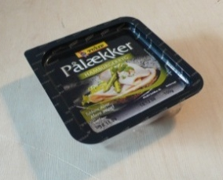  1 | 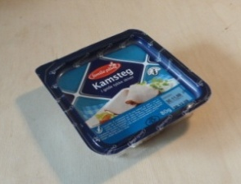  2 | 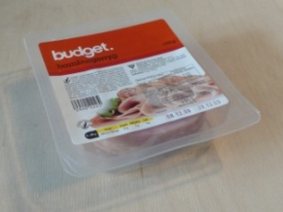  3
Figure 1 Three types of packaging were selected for testing.
Mechanical testing
On a previous occasion the Danish Technological Institute had measured the mechanical force necessary for opening Pålækker in order to assess whether the force used for opening the packaging was a critical parameter for the target group of Tulip. The mechanical test showed that the force necessary for opening the packaging was low (measured as 9 N based on 10 items) - 95 per cent of all users without any particular disabilities aged between 10 and 80 could easily open it.

Observations of users
The three packaging types were tested in a user-based study. It is important for Tulip that everyone, including the aged, who generally have less powerful hands and fingers, is able to open the packaging of their products. For this reason the users participating in the user survey consisted of young as well as old people, with and without physical ailments.
The user survey was intended to give Tulip a basic understanding of problem areas in existing packaging as well as an insight into other opportunities for development. Furthermore, the user survey also provided Tulip with an insight into the attitudes of various users toward different packaging types.
Plan for the testing: test subjects were asked to open and re-seal packaging. They were asked to think aloud while doing so and to look for instructions and other guidance on the packaging before opening the packaging.

4.3 Workshop and ideas generation
Tulip had gathered employees from the entire organisation in order for them to participate in a day of workshops. In the course of the workshop, videos recorded during the user study were analysed. In the following we have gathered the insights identified on this day.

Insights from the user survey
- Re-seal is important - users expect to be able to store cold sliced meat in the packaging after opening it.
- Re-seal ensures that the product will appear ”exciting” after the first day it has been opened.
- The size of flaps on the packaging should be increased (in particular in the upper layer).
- The choice of material is very important (a hard material is better!)
- Make sure that the joints on the top part of the packaging are not too hard, as this makes the packaging unnecessarily difficult to open.
- It is important that the opening is clearly visible.
- A rough/granulated surface makes getting a grip easier
- It may be a good idea to attach a ring to the opening
- A mechanism which ensures the separation of flaps should be attached

Ideas/focus from the workshop
During the workshop, in which employees from different Tulip departments participated along with packaging suppliers and an advertising agency, it was, among other things, noted that:
- Consumers rarely read instructions; the opening mechanism, consequently, has to be clearly visible.
- Consumers are prejudiced with regard to packaging types according to their own experience.

During the workshop different ideas for new packaging types were generated. You can see photos from the workshop below (Figure 2). It has been very important for Tulip to preserve the tray-based solution, as is evident from the proposals below. The different ideas incorporate different flap and ring-based solutions which utilise different materials and for which the flap/ring can be bent and pulled. Furthermore, different design solutions for the tray itself were suggested in order to make the location of the opening mechanism more obvious and to allow the consumer to get a better grip on the flap.

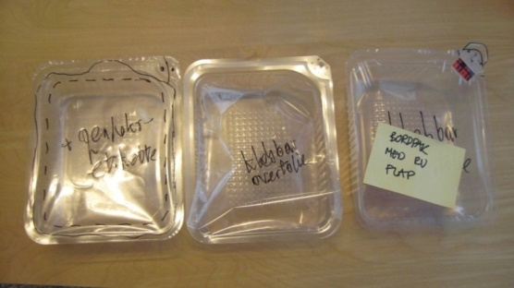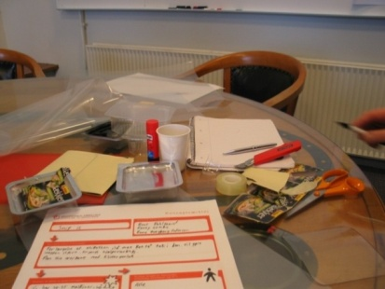
Figure 2 Illustration of the prototype formation made at the workshop at Tulip
4.4 Concept development and prototypes
In June 2008, in connection with the development of the packaging, Tulip, aided by Research Int., carried out an analysis of the key drivers of purchase. This study showed that "product display" is the most important factor, indexed at 100, while "useful for storage" indexed at 70, and "easy to close" and "easy to open" indexed at respectively 64 and 54.
For this reason, packaging development has been focusing on the aforementioned parameters. After ideas generation during the workshop, Tulip has continued their work on the new type of packaging; the central point being the development of a type of packaging with larger flaps which will make it easier to get a good grip on the packaging. Although the mechanical test showed that the packaging requires slightly more force to open (13 N based on 10 items) the consumer can transfer greater force due to improved grip. The knob in the packaging ensures that the consumer is able to separate flaps without using his or her nails. Furthermore, consumers can open the packaging from two corners instead of one. The new type of packaging is shown below.

4.5 The result
Based on this process, Tulip has, in week 47 of 2011, launched the product Pålækker in a new type of packaging for cold sliced meats with larger flaps (Figure 3). This packaging must provide the best possible protection during transport, storing and when it is stored by the consumer. At the same time, the packaging should differentiate the product and offer convenience to the consumer, including ease of opening and presentation when the product is served in the packaging type meant to be placed on the table.
In addition to the direct result: a new type of packaging, Tulip has, furthermore, gained a better understanding of the various considerations which are necessary for developing new types of packaging. Video-taped observations, in particular, proved to be effective tools for increasing the understanding of the user's behaviour and needs. The process has also created a higher degree of cohesion between the different departments of the company. This has been important as Tulip is a large company characterised by a high degree of efficiency. The process has, consequently, increased the internal cohesion of the company and created a better understanding of the objectives and motivations of different departments.

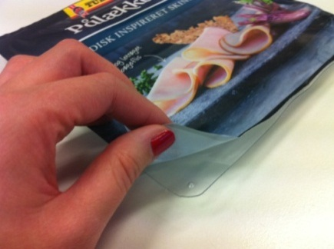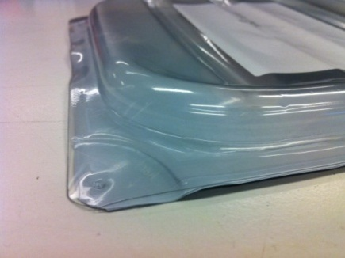
Figure 3 Illustration of the final packaging design for Tulip Pålækker
References
[1] Antvorskov H. & Geert B. R. (2011) Project report: “User-driven Guideline for the Industry: Accessible Packaging for Elderly and Disabled” http://www.userfriendlypackaging.com
[2] Statistics of Denmark. Forecast of Danish population 2010-2050. Date: 2010.10
http://www.statistikbanken.dk
[3] The Danish Rheumatism Association (2006) Internal note: ”De vigtigste resultater af undersøgelsen: Undersøgelse af forekomsten af nedsat arm- og håndfunktion i Danmark” Research made by Rambøll.
http://www.gigtforeningen.dk/files/ms/emballage/nedsat_haandfunktion_hos_voksne_danskere_2006.pdf
[4] Government Consumer Safety Research, Department of Trade and Industry, How to improve safe packaging disposal instructions, 1994
[5] Antvorskov H. (2007), “Retail and consumer attitude towards communicative packaging”, IAPRI Packaging Symposium, London, UK
[6] Agelab http://www.agelab.dk (2006) Date: 2012.03
[7] Orth, U. & Malkewitz, K (2008) Holistic Packaging and Consumer Brand Impressions. Journal of Marketing, vol 72, no 3, 64-81
[8] Hestad, M. (2006). "Pure shape - To realise intended meaning in practise". Design and semantics of form and movement (DeSForm), Northumbria University.
[9] Meyers,H. & Gerstman, R. (2005) the visionary Package – using packaging to build effective brands. Palgrave Macmillan: New York
[10] Young, S. (2004) Breaking down the barriers to packaging innovation. Design Management Review, vol. 15, no 1, 68-73
[11] Gough, K. (2006) On a Plate: making food packaging easier to use. I-design programme publication. Helen Hamlyn Research Center
[12] Yoxall, A., Luxmoore, J., Austin, M., Canty, L., Margrave, K. J., Richardson, C. J. , Wearn, J., Howard, I. C. & Lewis, R. (2007): Getting to Grips with Packaging: Using Ethnography and Computer Simulation to Understand Hand-Pack Interaction. Packaging Technology and Science, volume 20, p. 217-229.
[13] Consumer Affairs, Department of Trade and Industry, (2002) Strength data for design safety phase 1-2
[14] Heinö, R. & Åström, A. & Antvorskov, H. & Mattsson, M. & Østergaard, S. (2008) Easy Open Pack – Scientific background for the basis of an international standard for easy-to-open packages. Nordic cooperation project (NICe).

